SQ 2. What was the Industrial Revolution?

Unit Essential Question(s): Do the benefits of innovation outweigh the costs? For whom?
Supporting Question(s):
- What was the Industrial Revolution?
Objective(s):
- Describe what the Industrial Revolution was.

Vocabulary

Word/Phrase  (part of speech) | Definition
complex | consisting of many different and connected parts
economic | related to the use a country or region's wealth and resources
Great Britain | the main island of the United Kingdom, located off the northwest coast of France and occupied by England, Scotland, and Wales; Great Britain
Industrial Revolution | the period in which the production of goods shifted from hand production methods to complex machines. This period of industrialization resulted in social and economic changes. The Industrial Revolution started in Great Britain around 1750. The process of industrialization spread throughout the world in the following centuries.
industrialization | the process of developing manufacturing on a large scale
machine | a piece of equipment with a system of parts that work together to do or make something
manufacturing | the process of making a large number of something
manufacture | the process of making a large number of something
mechanization | the process of making something more mechanical or automatic by introducing machines
production | the act or process of making something
social | having to do with society, people living together in large groups
textile | cloth, or woven fabric

Objective: | What was the Industrial Revolution?  - SWBAT describe what the Industrial Revolution was IOT describe the advances in technology that led to urbanization and imperialism.

Introduction
Turn and Talk | ➡ Directions: Choose an item of clothing that either you or a classmate your is wearing today, discuss the following questions, then write your answers below.

1. Where was it made? | 2. How do you think it was made? | 3. How do you think your item would have been made in 1700? | 4. Why do you think the way we make clothing has changed?

What was the Industrial Revolution?

Industrial Revolution | the period in which the production of goods shifted from hand production methods to complex machines. This period of industrialization resulted in social and economic changes. The Industrial Revolution started in Great Britain around 1750. The process of industrialization spread throughout the world in the following centuries.

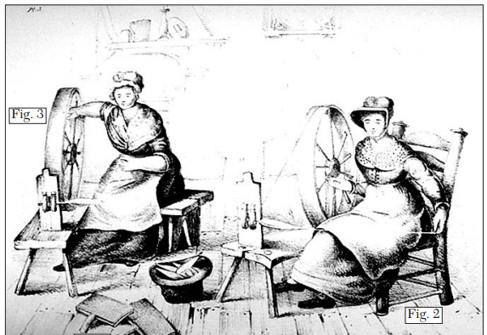  Illustration of two women working at home to make finished goods as part of the domestic system. |  | 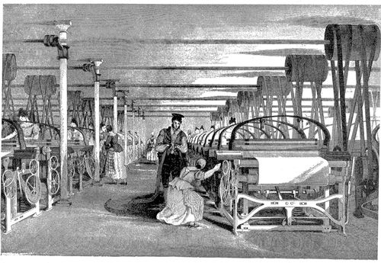  Illustration of a power loom weaving drawn by Thomas Allom (1835)  Image is courtesy of wikimedia commons and is public domain
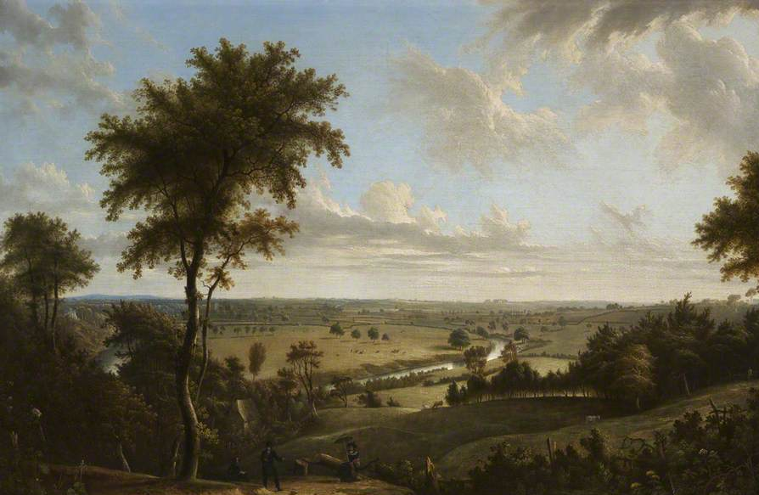  Manchester, England in 1820  Image is courtesy of wikimedia commons and is public domain |  | Manchester, England in 1852  Image is courtesy of wikimedia commons and is public domain

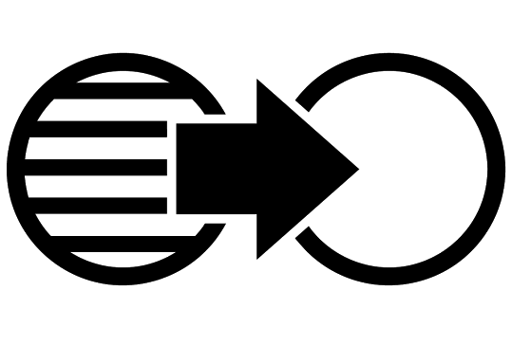  Connect Cause and Effect | Continuity and Change in Textile Manufacturing during the Industrial Revolution
➡ Directions: Read the text below and watch excerpts from the PBS video Mill Times and then complete the graphic organizers that follow.

Textile is another word for cloth, or woven fabric and the way textiles were made was one of the first changes that came about during the Industrial Revolution. The innovations in textile manufacturing led to more invention and the mechanization and industrialization of other work.

 | How were clothes made before the Industrial Revolution (0:00-1:05, 2:52-6:08)? |  | How were clothes made as a result of the Industrial Revolution (6:08-8:50)?

FA | SQ 2. What was the Industrial Revolution?  ➡ Directions: Based on what you have learned, complete the task below.
Contextualize | 1750 complex machines economic  Great Britain industrialization Industrial Revolution  The _________________________ was the period in which the production of goods shifted from hand production methods to _________________________. This period of _________________ resulted in social and ___________ changes.  The Industrial Revolution started in _______________ around ________. The process of industrialization spread throughout the world in the following centuries.

