Social Issues: The Three Estates
The estates system was the class structure or hierarchy in France before the French Revolution. The same groups that held power during the Middle Ages still had control after the Middle Ages ended.

clergy: people who work for the church like the Pope, bishops, and priests | nobility: wealthy landowners and people with high status in society | commoners: peasants and city-workers

Image 1  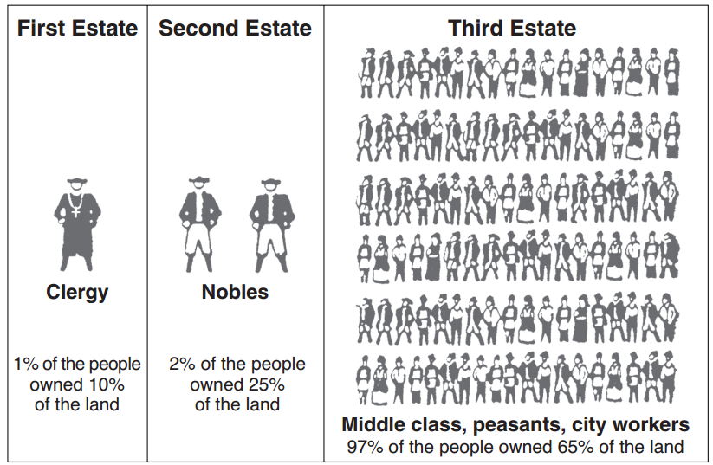  Source: Schwartz and O’Connor, Democracy and Nationalism, Globe Book Company (adapted) from the NYS Global History and Geography Regents Exam, August 2007  Image 2  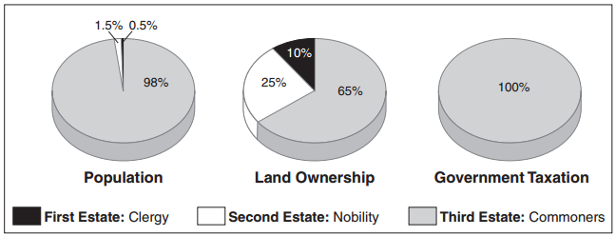  Source: Jackson J. Spielvogel, World History, Glencoe/McGraw-Hill, 2003 (adapted) from the NYS Global History and Geography Regents Exam, January 2007. | Image 3  The Three Estates, You Should Hope this Game Will Be Over Soon, 1788  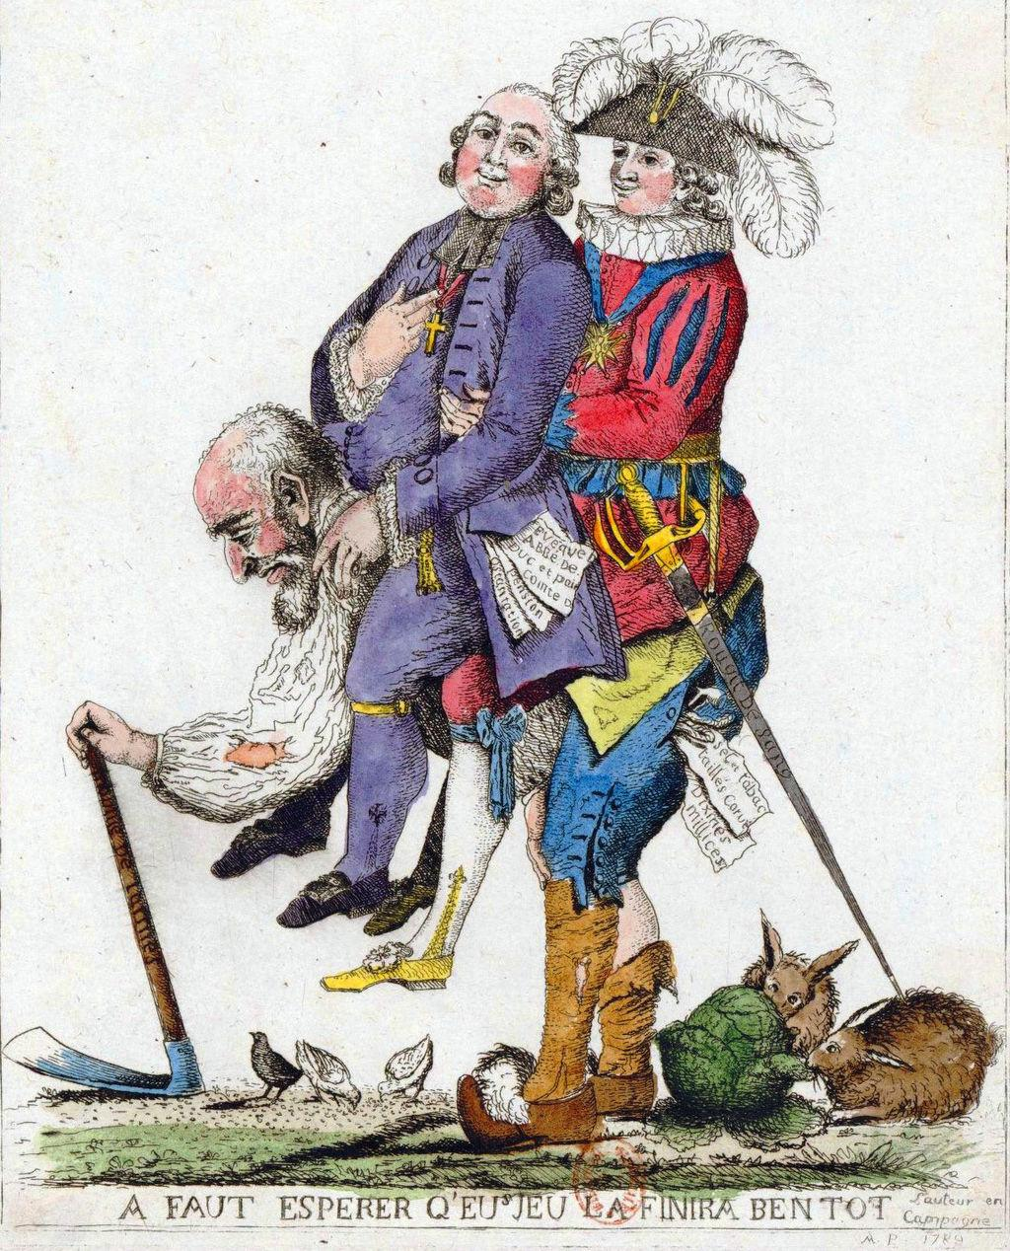  Source: Reproduced with permission from the National Museum of France from the NYS Social Studies ToolKit. http://www.c3teachers.org/inquiries/frenchrev/
1. Under the estates system, what were the three social classes?

2. Under the estates system, which social class was taxed the most?

3. Under the estates system, which class was the largest portion of the population?

4. What does image 3 reveal about social issues in pre-revolutionary France?

4. Based on the images above, identify the social issues facing pre-revolutionary France? | 5. How might these social issues lead the French people to revolt against their government?

Economic Issues: Debt and Rising Costs
Debt is money that is owed to someone else. When a country is in debt, it means that they have to pay the money back to whomever it is owed leaving less money for the country to pay for other things.
Palace of Versailles
The Palace of Versailles was a royal château [castle] in Versailles and was the center of political power in France from 1682 until 1789. Louis XVI and his wife Marie Antoinette lived in the palace before the French Revolution. They were known for throwing lavish parties.

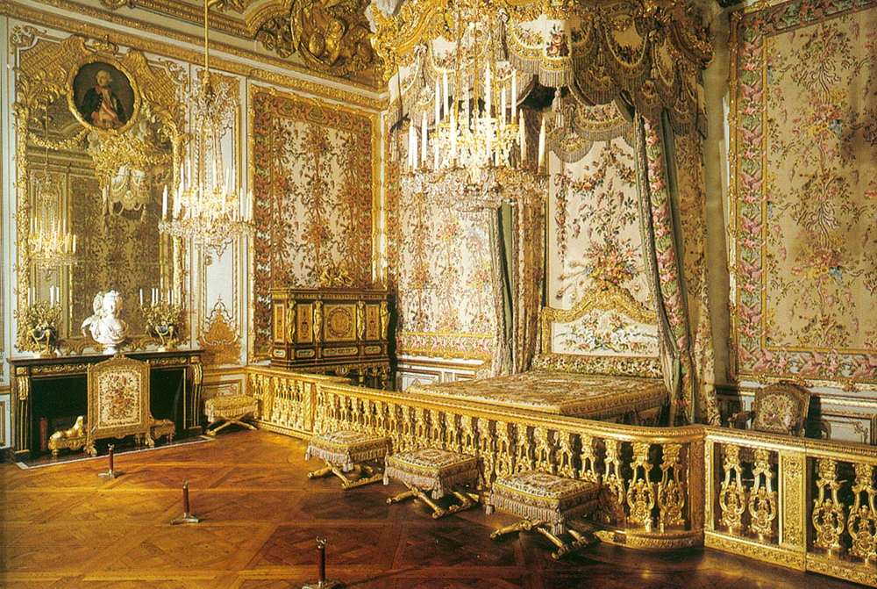  The Queen Marie Antoinette’s Chamber  Image is courtesy of Wikimedia Commons and is public domain. | 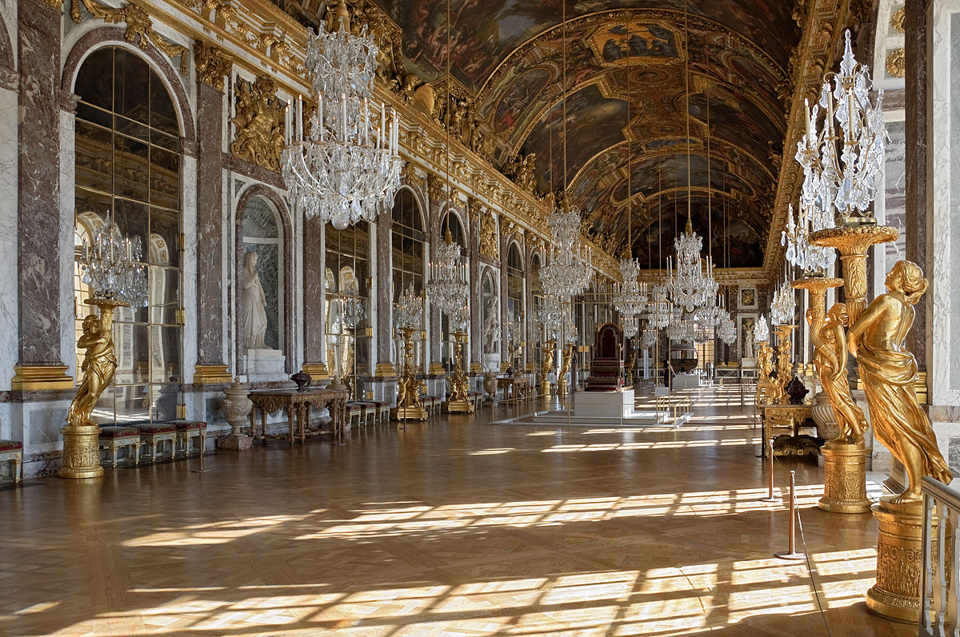  The Hall of Mirrors at the Palace of Versailles  Image is courtesy of Wikimedia Commons and is public domain.
France’s government was in enormous debt. King Louis XIV (1638-1715), Louis XV (1710-1774), and Louis XVI (1754-1793) added to the debt, borrowing money to finance the following:

Date | Event that Increased the French Debt
1678-1789 | Building of, additions to, and upkeep of the Palace of Versailles
1756-1763 | Seven Years’ War: Fought against their rivals at the time, Great Britain, and several other European powers in Europe and North America.
1775-1783 | American Revolution: France lended 1.3 billion livres, soldiers, and ships to the American colonists in their fight against the British.
1678-1789 | Extravagant lifestyles of Louis XVI and Marie-Antoinette

6. What did the kings of France spend money on that put the country into debt?

7. Which of these costs seem justified? Which costs seem unjustified?

