Geography and History Activity
Challenge and Transition in East Asia

Foreign Inroads into China

netw rks

The main concerns of political geographers are the state and its territory—for example, with the relationships between citizens and governments and individual states’ relationships with external powers. One example of political geography can be seen
in the map below, which shows the spheres of influence in China in 1900.

A sphere of influence is the claim by a state that it has predominant or even exclusive control over a foreign territory or area. Sometimes this term refers to a claim that other countries may or may not recognize to be true. Other times, it refers to a legal agreement by which other states promise not to interfere within the sphere of influence. It is the latter, legal sense of the term that applies to the area shown on
this map.

Spheres of influence can be considered enclaves or exclaves. An enclave is a foreign territory located within a state but not under its jurisdiction, or legal control. An exclave is a portion of a country that is physically separated from the main territory and surrounded by the land of another country. So whether an area is called an enclave or an exclave depends on one’s point of view. To a Chinese national in 1900, the spheres of influence shown on the map would be considered exclaves; to non-Chinese occupants, the spheres of influence would be considered enclaves.

Another concept related to spheres of influence is extraterritoriality, or diplomatic immunity. According to international law, extraterritoriality refers to the fact that foreign states or international organizations and their official representatives are immune from the legal jurisdiction of the country in which they are present. In other words, such entities and individuals are exempt from local police interference, judicial process, and other means of constraint while they are within foreign territory, for they are considered to be under the legal jurisdiction of their own home country. This means that they cannot be sued or arrested by the local authorities.

Geography and History Activity Cont.
Challenge and Transition in East Asia
netw rks
Spheres of Inﬂuence in China, 1900

Qingdao
Yellow Sea

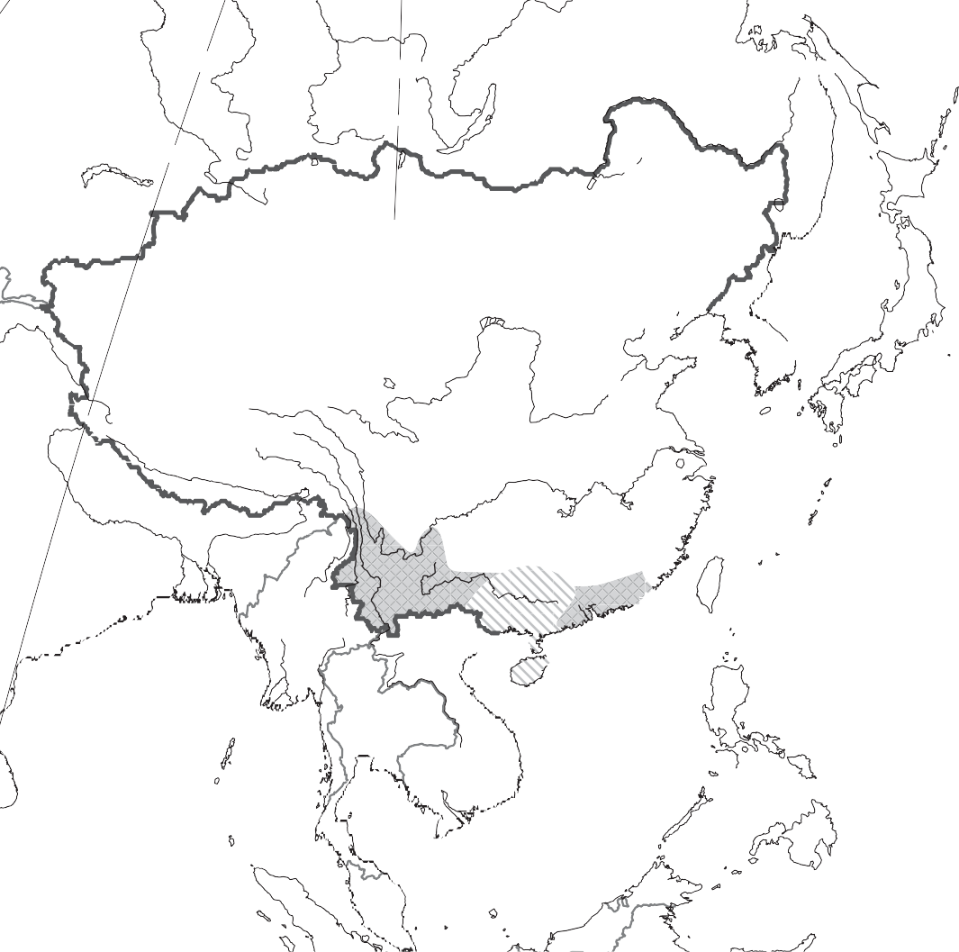Caption: By 1900, Britain, France, Germany, Japan, and Russia had established spheres of influence in China.
80°E
100°E SI B E R I A 120°E
140°E
160°E
RUSSIA
MANCHURIA
MONGOLIA

Beijing Tianjin
Dandong Port
Arthur
Vladivostok
Sea of Japan
(East Sea)
JAPAN
Tokyo (Edo)
KOREA
C H I N A
TIBE T
Nanjing
Shanghai Hangzhou
PACI F I C O CE A N
SIKKIM
Yadong
East China
Fuzhou Sea
GUANGDONG
INDIA
BURMA (MYANMAR)
Guangzhou Taiping
Zhanjiang
Hong Kong
Macao
LAOS
(Macau)
China
Bay of Bengal
SIAM
(T D)
HAILAN
FRENCH
I A
NDOCHIN
South China Sea
PHILIPPINES
0
0
1,000 miles
1,000 km
Two-Point Equidistant projection
Spheres of Influence
British French German Japanese Russian
Treaty Ports* American British French Japanese Portuguese
*Granted by China after Opium Wars
French and British

Directions: Answer the questions below in the space provided.

Understanding Concepts
- Interpreting According to the map, which European country had the most strategic sphere of influence in China? Why?

Geography and History Activity Cont.
Challenge and Transition in East Asia

netw rks

- Analyzing Complete the following graphic organizer to show the spheres of influence in China in 1900 by labeling each part according to the information on the map. The organizer has been started for you.

Spheres of Influence in China (by percent)

Japan Germany

4.
0 10 20 30 40 50 60

- Analyzing Imagine that you are a Chinese national who lives in a sphere of influence in 1900. Would you be residing in an enclave or an exclave? Explain your answer.

Applying Concepts
- Drawing Conclusions By 1900, Western powers had secured unilateral—that is, not reciprocal—extraterritorial rights for their citizens in China and several other countries with the idea that these “uncivilized” states were not capable of establishing justice. Based on what you have learned about China during this time, why do you think the Chinese agreed to this arrangement?

- Making Connections Extraterritoriality can be a good thing or a bad thing, depending on the circumstances. Give an example of what you would regard as a good application of the concept, and then give an example of a bad application of the concept.

