Japanese Imperialism and Interwar Period
State Standard:
W.41
Explain how economic instability, nationalism, and political disillusionment in Germany and Japan led to the rise of totalitarian regimes.

Objective:
SWBAT construct and communicate arguments citing evidence by predicting
outcomes IOT explain how economic instability, nationalism, and political disillusionment in Germany and Japan led to the rise of totalitarian regimes.

1 | Why did Japan become an imperial nation?  Objectives: Identify the causes for Japanese imperialism.
Introduction
Directions: Examine the images below and answer the questions that follow.
REVIEW and PREDICT
European countries industrialized in the late 1700s and 1800s.  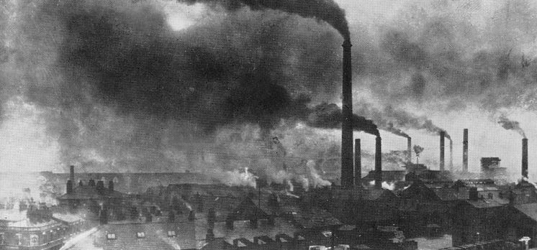  Photograph of Widnes, England in the late 19th century.  Image is courtesy of wikimedia commons and is in the pubic domain  1. What natural resources did they need to support the process of industrialization?  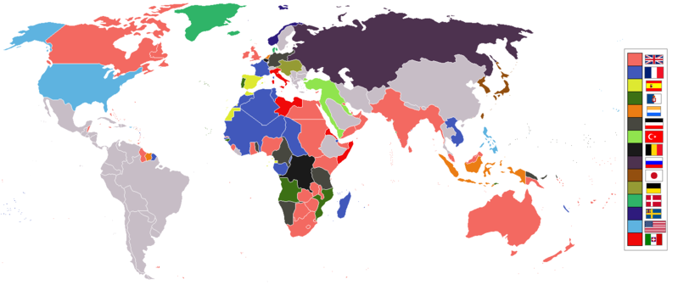  World empires and colonies in 1914, just before the First World War.  Image is courtesy of wikimedia commons and is is licensed under the Creative Commons Attribution 3.0 Unported license  .  2. What did European countries do starting in the mid-1800s to acquire more natural resources? | In the late 1800s, Japan entered a period of industrialization also.  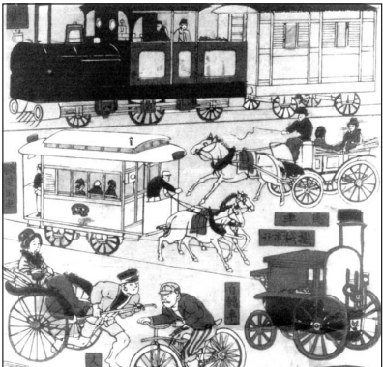  Source: James L. Huffman, Modern Japan, A History in Documents, Oxford University Press from the NYS Global History and Geography Regents Exam, June 2010.  3. What was the name of the Japanese period of industrialization that started in the late 1800s?  4. The islands of Japan, unlike most countries in Europe, did not naturally have the raw materials needed to industrialize further. What do you predict Japan will do to support industrialization?
Japanese Geography and the Problem with Industrialization
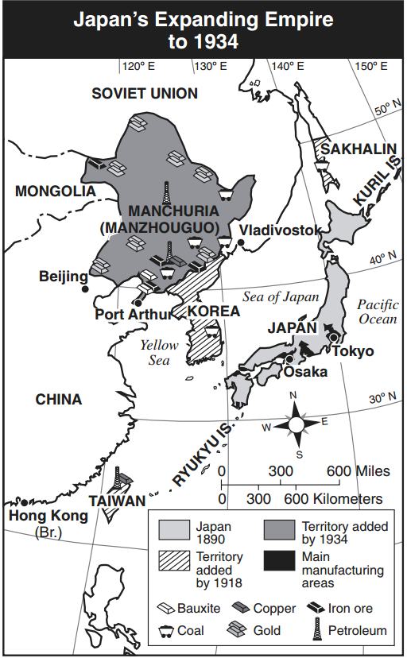
Source: Elisabeth Gaynor Ellis and Anthony Esler, World History Connections to Today: The Modern Era, Prentice-Hall (adapte(4) from the NYS Global History and Geography Regents Exam, January 2003.
During the Meiji Restoration (1868-1890), the Japanese studied the political, economic, and social institutions of the Western powers and selectively adopted certain institutions to meet their needs. For example, they modeled their constitution and government after Western European ones, but gave their emperor more power than European kings had in limited monarchies. They also elevated the status of merchants, a class that had been looked down upon in Japanese society but was respected in the West. A national military and universal conscription were established, and compulsory public education was introduced both to teach the skills needed for the new nation and to teach values of citizenship in all Japanese.

Most importantly, the Japanese industrialized during the Meiji Restoration and experienced many of the same effects that England had earlier in the century. Cities grew as more Japanese moved from farming into jobs in factories and offices. In the countryside larger landlords came to own more and more land, and the number of poor tenants increased.

Unlike England, who had an abundance of coal and other natural resources necessary for industrialization, Japan had very few of these raw materials. Instead, the Japanese traded for raw materials to fuel their factories and make their products. In the 1920s, for example, the Japanese traded goods like steel and silk stockings, which were very popular in the United States, for raw materials. The strategy of trading for natural resources worked well for Japan until the Great Depression hit the world in 1929. [You will learn more about the Great Depression in a later lesson.] As a result of the Great Depression, foreign governments and companies had little money to spend on Japanese goods.

Source: Adapted from “Japan’s Modern History: An Outline of the Period.” Asia for Educators. http://afe.easia.columbia.edu/timelines/japan_modern_timeline.htm
1. In terms of access to natural resources, how did Japan differ from England? | 2. How did Japan acquire the natural resources needed for industrialization before the Great Depression? | 3. What was the effect of the Great Depression on Japan’s ability to trade for raw materials?
Imperial Japan
1868-1912
Meiji Restoration
1894
Japan Wins First Sino-Japanese War

1904-1905
Japan Wins Russo-Japanese War
1926
Hirohito Becomes Emperor of Japan

1919
Japan takes over Germany’s possessions in East Asia

September, 18 1931
Manchurian Incident
1933
Japan Leaves League of Nations
1937
Second Sino-Japanese War
Japan Invades China

1937-1938
Nanking Massacre

Note: Timeline is not to scale.
1940
Japanese occupation of French Indo China

Timeline of Japanese Imperialism
To get the raw materials they needed, the Japanese decided to do what European had started earlier in the century: imperialize. First, the Japanese, with their new industrial strength and modern weapons, renegotiated the unequal treaties they made with Western nations like the United States when Commodore Matthew Perry forced them to open up to trade. Then, Japan fought a war against China in 1894-95 over the control of Korea and gained Taiwan, Japan's first colony. In 1902, Japan signed an alliance with Great Britain, which signified a dramatic increase in international status, and in 1904-5, Japan won a war against Russia, one of the major Western powers. In the process Japan expanded its empire, annexing Korea in 1910. Japan was allied with the United States and Britain in World War I, and expected territorial gains at the Versailles peace conference in 1919. Instead Japan met with strong opposition from the United States, and again learned the lesson that the West regarded imperialism very differently if it was the imperialism of an Asian nation rather than a European power.

Source: Adapted from “Japan’s Modern History: An Outline of the Period.” Asia for Educators. http://afe.easia.columbia.edu/timelines/japan_modern_timeline.htm

4. In the 1900s, before the Great Depression, how did Japan acquire raw materials for industrialization? | 5. Which countries/regions did Japan conquer between 1894 and 1940? | 6. The text states that after the Versailles Peace Conference, that Japan “learned the lesson that the West regarded imperialism very differently if it was the imperialism of an Asian nation rather than a European power.” Explain what this means.

Summarize: Why did Japan become an imperial nation in the 20th century?

2 | What were the effects of Japanese imperialism?  Objectives: Describe the effects of Japanese imperialism.

The Manchurian Incident and Japanese Aggression Leading up to WWII

Watch this video on the Japanese takeover of Manchuria (start-6:25), read the text below, and answer the accompanying questions.
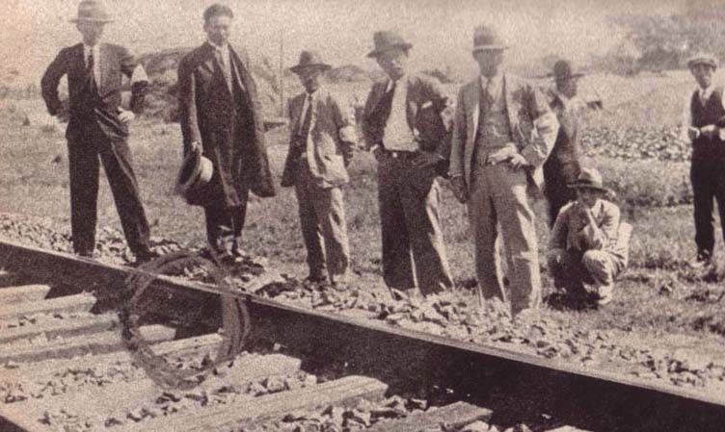
This photograph of Japanese experts examining the section of railway in Manchuria where military leaders claim the Chinese sabotaged the tracks was printed in a Japanese newspaper soon after the Manchurian Incident in 1931.
Image is courtesy of wikimedia commons and is in the public domain

The setbacks and insults from abroad, combined with an economic depression, sowed public frustration with the political leadership in Japan. A group of military leaders stationed in Northeastern China, in a region called Manchuria, who were there to protect a Japanese railway, wanted full control over the region. They knew, however, that unprovoked aggression would be condemned by the international community.

In 1931, they came up with a plan. On September 18, they detonated dynamite close to a section of Japanese railway and blamed it on the Chinese. They used the explosion as an excuse to mobilize their army, invade all of Manchuria and rule the region. Six months later, Manchuria became Manchukuo, a Japanese territory.

The Chinese called on the League of Nations to condemn the act and stop the Japanese, but the League did not act and the Japanese left the League of Nations. This event showed how weak the League of Nations was and how ineffective it was at peacekeeping after WWI.

After the Manchurian Incident, the military-industrial machine went into high gear, pulling Japan out of its economic depression as it continued to expand Japanese power across the Far East. As Holland, France, and Germany were enveloped in turmoil in Europe, Japan looked to replace them in Asia. Japanese troops invaded China in 1937, and French Indochina in 1940, setting up puppet governments to administer areas too vast to be controlled by the Japanese armies.

Western countries, especially the United States, grew concerned over Japan’s increased aggression.

Source: Adapted from “Japan’s Modern History: An Outline of the Period.” Asia for Educators. http://afe.easia.columbia.edu/timelines/japan_modern_timeline.htm

1. Based on the video (start- 1:45), describe Japan in the 1920s before the Great Depression in 1929. | 2. What was the Manchurian Incident? Why did it happen?
3. What were the effects of the Manchurian incident for the Chinese? For the Japanese?

The Nanking Massacre
Watch this news report from CCTV on the Japanese invasion of China in 1937 and the Massacre of Nanking, read the text below, and answer the accompanying questions.
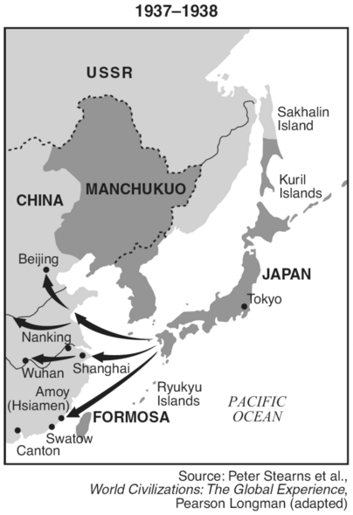
In 1937, the Japanese invaded China, starting the Second Sino-Japanese War. They were successful in taking over most of the eastern coast of China and its major ports.

After invading and securing the capital, Nanking [also written Nanjing], an event known as the Nanking Massacre, also called Rape of Nanking, (December 1937–January 1938) took place. It was a period of mass killing and ravaging of Chinese citizens and surrendered soldiers by soldiers of the Japanese Imperial Army. The number of Chinese killed in the massacre has been subject to much debate, with most estimates ranging from 100,000 to more than 300,000.

The destruction of Nanking—which had been the capital of the Nationalist Chinese from 1928 to 1937—was ordered by Matsui Iwane, commanding general of the Central China Front Army that captured the city. Over the next several weeks, Japanese soldiers carried out Matsui’s orders, perpetrating numerous mass executions and tens of thousands of rapes. The army looted and burned the surrounding towns and the city, destroying more than a third of its buildings. In 1940, the Japanese made Nanking the capital of their Chinese puppet government headed by Wang Ching-wei (Wang Jingwei). Shortly after the end of World War II, Matsui and Tani Hisao, a lieutenant general who had personally participated in acts of murder and rape, were found guilty of war crimes by the International Military Tribunal for the Far East and were executed.
Source: Encyclopædia Britannica Online, s. v. "Nanjing Massacre", accessed January 18, 2016, http://www.britannica.com/event/Nanjing-Massacre.

Answer the following questions regarding the Nanking Massacre.  5a. When did it take place?  5b. Where did it take place?  5c. Who was involved?  5d. What occurred? | 6. China was a member of the League of Nations in 1937 and an important trade partner with the United States, Great Britain, and other European countries. How might Japan’s invasion of China and the Nanking Massacre have affected relations between Japan and Western powers? | 7. How do you think the Nanking Massacre will affect Japanese and Chinese relations later in history?

Describe the effects of Japanese imperialism on China.

Regents Multiple Choice Check for Understanding
Base your answer to question 4 on the map below and on your knowledge of social studies.
Growth of the Japanese Empire, 1931–41
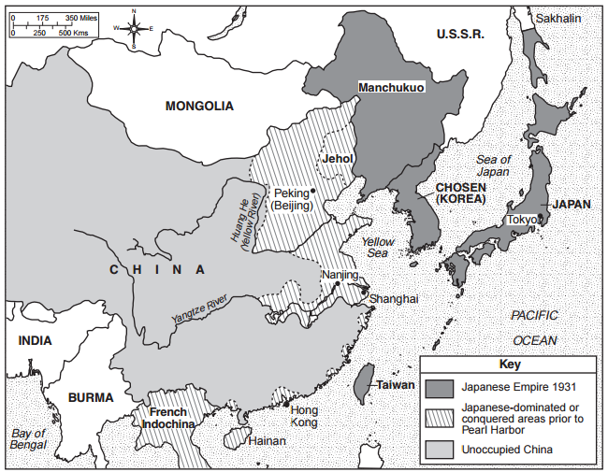
Source: Historical Maps on File, Revised Edition, Volume II, Facts on File (adapted from NYS Global History and Geography Regents Exam, June 2013.

4. Based on the information provided by this map, how did the growth of the Japanese Empire affect China?
(1) China acquired Japanese military technology.
(2) China invaded French Indochina.
(3) China was forced to adopt Korean culture.
(4) China lost control of many of its eastern seaports.

