Lesson 1: The Magna Carta
Station One – What is the Magna Carta? Watch the video “What is Magna Carta” and answer the questions below.
- The Magna Carta was signed in the year ______________.
- What were 2 reasons John was seen as a terrible king?
- What does the most famous clause of the Magna Carta give to English citizens?
- Name one document that was influenced by the Magna Carta.
Station Two: Read passages from Magna Carta
Magna Carta was a contract that limited the power of the king in England. Only four of the sixty-three clauses in Magna Carta are still valid today and of those four, clauses 39 and 40 are the most famous. For each of those clauses below, rewrite them in your own words and explain how the clause limited the power of the king.
Clause 39: “No free man shall be seized, imprisoned, dispossessed [to have something you own taken away from you], outlawed, exiled or ruined in any way, nor in any way proceeded against, except by the lawful judgement of his peers and the law of the land.
In your own words: | How did this clause limit the king’s power?
Clause 40: “To no one will we sell, to no one will we deny or delay right or justice.”
In your own words: | How did this clause limit the king’s power?

Read the passages from the Magna Carta below and answer the DBQ questions on the bottom left.

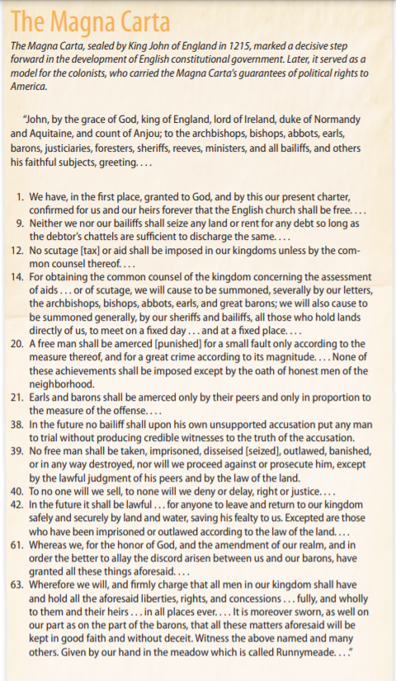
- Identify: Which paragraph discusses the idea of a punishment “fitting a crime”?

- Which paragraphs address an individual’s right to a trial by jury?

