Image A  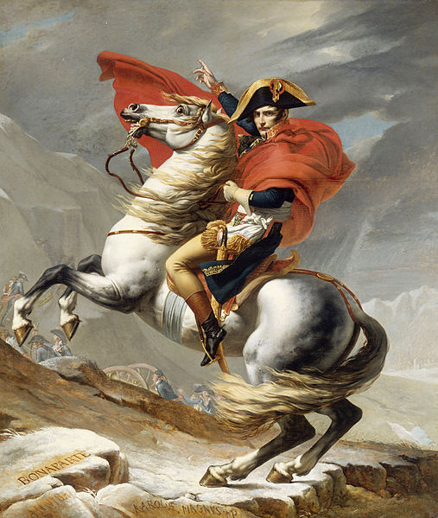  Bonaparte Crossing the Grand Saint-Bernard Pass by Jérôme-Martin Langlois and Jacques-Louis David, 1802.  Image is courtesy of Wikimedia Commons and is in the public domain | Image B  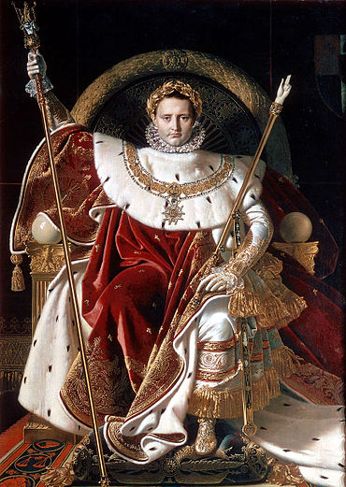  Napoleon on his Imperial throne. by Jean-Auguste-Dominique Ingres, 1806.  Image is courtesy of Wikimedia Commons and is in the public domain | Image C  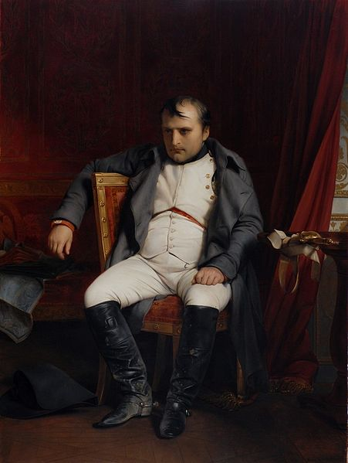  Napoléon Bonaparte abdicated in Fontainebleau by Paul Delaroche, 1845  Image is courtesy of Wikimedia Commons and is in the public domain
Describe how Napoleon is depicted in Image A. | Describe how Napoleon is depicted in Image B. | Describe how Napoleon is depicted in Image C.
Based on the progression of the images, how did the perception of Napoleon change over time?

