SQ 8. How did Europeans, the Japanese, and the United States gain, consolidate, and maintain power in China?

Unit Essential Question(s): How do nations seek power and at what cost?
Supporting Question(s): How did Europeans, the Japanese, and the United States gain, consolidate, and maintain power in China?
Objective(s):
- Contextualize imperialism in China.
- Describe how Europeans and the Japanese gained, consolidated, and maintained power in China.

Vocabulary

Word/Phrase  (part of speech) | Definition
addict | a person who depends on something, such as a drug, that is usually harmful and cannot be easily given up
addictive | tending to cause one to become addicted
artillery | large weapons used in land battles, such as cannons or rockets
astronomically | enormously; immensely
barter | to trade services or things for other services or things without using money
bribe | something promised or given to a person as a way of getting that person to do a certain thing
China | a country in eastern Asia. China is currently called the People's Republic of China. Beijing is the capital of China.
compensation | something that you get in return for doing something
confiscate | to take by the power of authority
concession | something given away
consolidate | to join together or combine
enormous | very large in size or amount; huge
exploitation | the selfish or unfair using of someone or something for one's own advantage
extraterritoriality | the state of being exempt from local law
Hong Kong | a region off the southern coast of China. Hong Kong was once a British colony but was returned to Chinese rule in 1997
imperialism | the policy of extending a country or empire's power and influence over another by taking over its land and/or government
missionary | a person sent to promote a religion in a foreign place
monopoly | the control of trade or business by one company
musket | a heavy gun with a long barrel. Muskets were carried on the shoulder. They were used over three hundred years ago, before rifles were invented
opium | an addictive drug derived from one variety of poppy, containing various narcotic substances, and producing calm, stupor, sleep, or relief from pain
Opium Wars | (1839-1842; 1856-1860) two wars fought in the mid-19th century between China and the British Empire over the British trade of opium and China’s independence
point of view | an opinion; a claim
poppy | a plant with brightly colored flowers that is grown in mild climates and can be used to create the drugs opium and heroine
possession | something that is owned
scheme | a plan or plot
smuggle | to bring in or take out in secret
sphere of influence | a country or an area of a country that another country has the power to affect what happens there
trade imbalance | a situation in which one country sells more goods and makes more money in another country than the other country sells and makes in the first country
Treaty of Nanjing | (1842) the agreement signed at the end of the first Opium War that was the first of many unequal treaties China was forced to sign in the late 19th and early 20th centuries
unequal treaty | an agreement that greatly favors one country over another
victim | a person who is hurt or killed by someone or something
woolen fabric | cloth made of sheep’s wool
Objective: | How did Europeans, the Japanese, and the United States gain, consolidate, and maintain power in China?  - Contextualize imperialism in China.  - Describe how Europeans, the Japanese, and the United States gained, consolidated, and maintained power in China.

Think Like a Geographer | Introduction  ➡Directions: Examine the maps below and complete the See-Think-Wonder chart.

East Asia, 1789  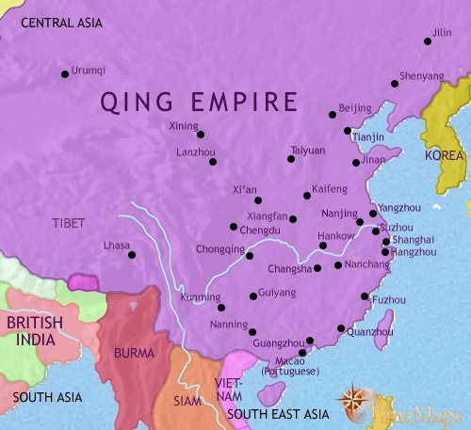  Source: Timemaps.com | East Asia, 1837  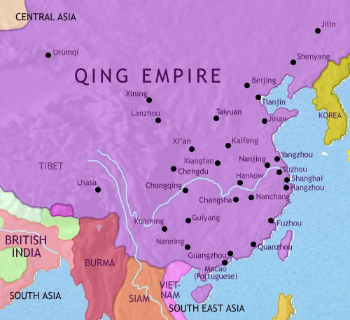  Source: Timemaps.com | East Asia, 1871  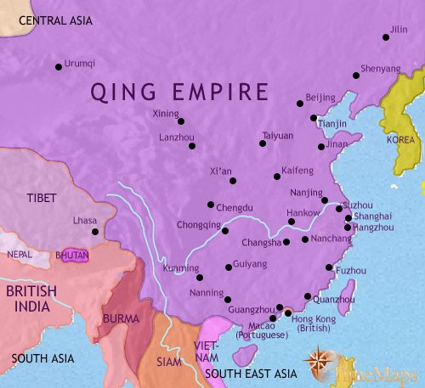  Source: Timemaps.com | East Asia, 1914  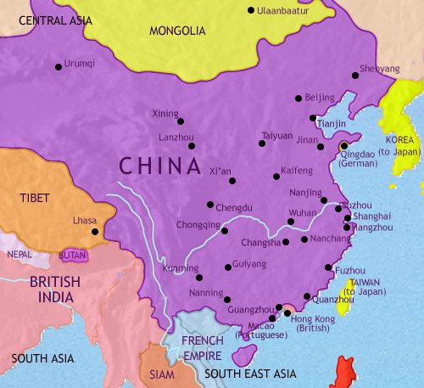  Source: Timemaps.com

See  What do you see in the maps? | Think  What do you think changed in East Asia from the 17th to 20th centuries? | Wonder  What questions do you have about the information in the maps?

Categorize | Corroborate | Document Analysis Activity: How did Europeans, the Japanese, and the United States gain, consolidate, and maintain power in China?  ➡Directions: Examine the videos, images, and text on imperialism in China and annotate as you read by placing a “G” next to examples of methods that the British used to gain power in India, a “C” next to examples of methods they used to consolidate their power, and an “M” next to examples of methods used to maintain power and add information to this graphic organizer.
First Opium War (1839-1842)
Watch this History Channel Clip about the Opium Wars from Mankind: The Story of All of Us and this clip from from another documentary on the Opium Wars (0:35-7:20) then read the information below.

In the 19th century, the British had a trade imbalance with China, meaning that they were buying a lot of Chinese goods, but not selling very much to the Chinese. The main reason for this imbalance was that the British became a nation of tea drinkers and the demand for Chinese tea rose astronomically. It is estimated that the average London worker spent five percent of his or her total household budget on tea. To prevent a trade imbalance, the British tried to sell more of their own products to China, but there was not much demand for products like heavy woolen fabrics in a country accustomed to either cotton or silk clothing.  Though the Qing Emperor declared that his country had no interest in European goods, the British found one product that they could profit from in China: opium. Opium is an addictive drug that comes from the poppy plant and is usually smoked. It is grown in regions of Central Asia that during the 18th, 19th, and part of the 20th century were a part of the British colony of India. The British did all they could to increase the trade. They bribed officials, helped the Chinese work out elaborate smuggling schemes to get the opium into China's interior, and distributed free samples of the drug to innocent victims. | 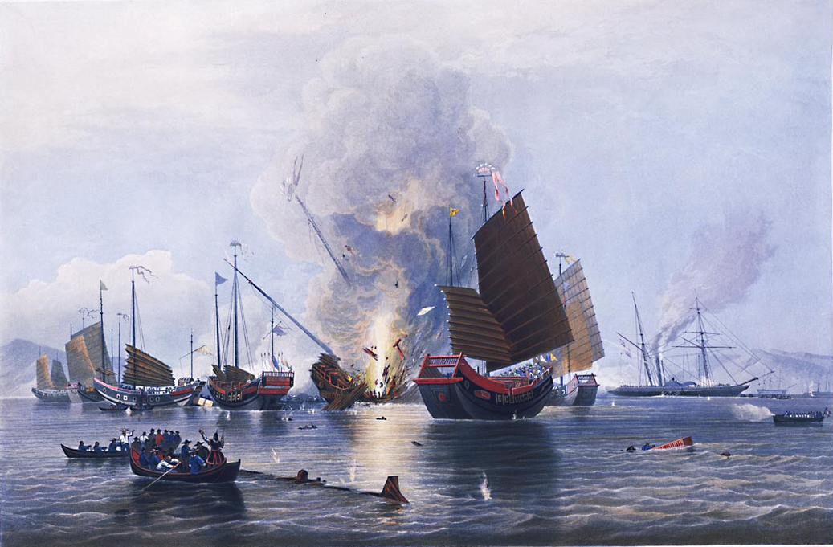  Painting of The East India Company’s iron steam ship Nemesis, commanded by Lieutenant W. H. Hall, with boats from the Sulphur, Calliope, Larneand Starling, destroying the Chinese war junks in Anson’s Bay, on 7 January 1841 during the first Opium War.  Image is courtesy of wikimedia commons and is in the public domain

The cost to China was enormous. The drug weakened a large percentage of the population (some estimate that 10 percent of the population regularly used opium by the late nineteenth century), and silver began to flow out of the country to pay for the opium. Many of the economic problems China faced later were either directly or indirectly traced to the opium trade. The government debated whether to legalize the drug through a government monopoly like that on salt, hoping to barter Chinese goods in return for opium. Instead, the Chinese outlawed the drug and in 1838 the emperor decided to send one of his most able officials, Lin Tse-hsu (Lin Zexu, 1785-1850), to Canton (Guangzhou) to do whatever was necessary to end the drug traffic forever.  Lin was able to put his first two proposals into effect easily. Addicts were rounded up, forcibly treated, and domestic drug dealers were harshly punished. His third objective — to confiscate foreign stores and force foreign merchants to sign pledges of good conduct, agreeing never to trade in opium and to be punished by Chinese law if ever found in violation — eventually brought war. Opinion in England was divided: Some British felt morally uneasy about the trade, but they were overruled by those who wanted to increase England's trade with China and teach the Chinese a lesson.  Western military weapons, including percussion lock muskets, heavy artillery, and paddlewheel gunboats, were far superior to China's weapons. The result was a disaster for the Chinese. By the summer of 1842 British ships were victorious and were even preparing to shell the old capital, Nanking (Nanjing), in central China. The emperor therefore had no choice but to accept the British demands and sign a peace agreement. This agreement, the first of the "unequal treaties," opened China to the West and marked the beginning of Western exploitation of the nation. | 1. What is opium? Why was it valuable to the British?
 | 2. How did the Chinese government respond to the British opium trade?
 | 3. Who won the Opium Wars? Why were they victorious?
Treaty of Nanjing, 1842
The Treaty of Nanjing was signed at the end of the first Opium War and was the first of many unequal treaties that the Chinese were forced to sign with imperialist nations. The treaty stated that: - the British gained possession of the island of Hong Kong which it held until 1997 - several Chinese cities were forced to trade with British merchants - the Chinese had to pay the British 21 million ounces of silver - British citizens gained the right of extraterritoriality. Extraterritoriality is the state of being exempt from local laws, so the British, while in China, could follow their own laws and could not be arrested or punished by the Chinese. - Christian missionaries were allowed to preach in China - the British would have exclusive rights (as opposed to other nations) to trade with the Chinese in British “spheres of influence.” A sphere of influence is a country or an area of a country that another country has the power to affect what happens there. A French political cartoon from 1898 entitled, “China- the cake of kings and...of emperors.” Image is courtesy of wikimedia commons and is in the public domain | 4. Identify three ways the British benefited from the Treaty of Nanjing.
 | 5. What is extraterritoriality?
 | 6. What is a “sphere of influence”?

Other Unequal Treaties
Between 1842 and 1933, the Chinese were defeated in a number of wars with European powers, the United States, and Japan. Each conflict ended with treaties which included concessions similar to the Nanjing Treaty. They resulted in more Chinese ports open for trade, territory given to the winners of the war, and the right of extraterritoriality for the citizens of more nations. Most of these countries were given spheres of influence in Chinese cities in which to trade.  Spheres of Influence in China, 1895–1914 Source: Historical Maps on File (adapted) from the NYS Global History and Geography Regents Exam, June 2012. List of Some of the Unequal Treaties Treaty Year Imposing Nation Treaty of Nanjing 1842 British Empire Treaty of Wanghia 1844 United States Treaty of Whampoa 1844 French colonial empire Treaty of Canton 1847 United Kingdoms of Sweden and Norway Treaty of Aigun 1858 Russian Empire Treaty of Tientsin 1858 French colonial empire, British Empire, Russian Empire, United States Convention of Peking 1860 British Empire, French colonial empire, Russian Empire Treaty of Tientsin (1885) 1885 French colonial empire Sino-Portuguese Treaty of Peking 1887 Kingdom of Portugal Treaty of Shimonoseki 1895 Empire of Japan Li-Lobanov Treaty 1896 Russian Empire Boxer Protocol 1901 British Empire, United States, the Empire of Japan, Russian Empire, French colonial empire, German Empire, Kingdom of Italy, Austro-Hungarian Empire, the Kingdom of Belgium, the Kingdom of Spain, the Kingdom of the Netherlands Simla Accord 1914 British Empire Twenty-One Demands 1915 Empire of Japan Source of list: https://en.wikipedia.org/wiki/Unequal_treaty | 7. If you were a European, American, or Japanese merchant, what might your point of view be concerning the unequal treaties with China?
 | 8. If you were a Chinese person, what might your point of view be concerning the unequal treaties and the Chinese government that signed them?

FA | SQ 8. How did Europeans, the Japanese, and the United States gain, consolidate, and maintain power in China?
Contextualize  Corroborate | ➡Directions: Respond to the questions below to contextualize European and Japanese imperialism in China and complete this graphic organizer..  Event: European and Japanese Imperialism in China  Who?  individuals, groups of people, regions, nations involved  When?  date, year, era, “before __,” “after __”  Where?  continents, regions, countries, geographic features nearby, describe the geography if relevant  How?  describe the process that took place  Why?  use words and phrases like “led to,” because, and so to show connections between events and to explain why  Combined Contextualization:  Why did it happen when and where it happened?  Combine your responses from above to contextualize the event.

