SQ 13. Why did Japan industrialize during the Meiji Period? How did industrialization affect Japan?

Unit Essential Question(s): Do the benefits of innovation outweigh the costs? For whom?
Supporting Question(s):
- Why did Japan industrialize during the Meiji Period? How did industrialization affect Japan?
Objective(s):
- Explain the social, political, and economic impacts of industrialization on Japan during the Meiji Restoration.

Vocabulary
Word/Phrase | Definition
bicameral | having two legislative chambers or branches
Commodore Matthew Perry | (1794- 1858) a commodore in the United States navy who forced the Japanese to open their country to western merchants in 1853
constitution | the set of basic laws and principles by which a nation, state, or other organization is governed
detain | to stop or keep from moving
economic | related to the use a country or region's wealth and resources
electorate | those who can participate in an election; qualified voters
enlighten | to give information or knowledge to
feudal system (feudalism) | a decentralized system of power in which land owned by a powerful person is divided up and given to others in exchange for work and a promise to fight for the interests of the land owner
formidable | exceptionally difficult; daunting
imitation | a copy of something else
imperial | having to do with an empire or an emperor
industrial | related to turning raw materials into manufactured goods
industrialize | to make something industrial
intellectual | of or having to do with the ideas
isolate | to set apart in order to make alone
Japan | a country in eastern Asia made up of islands in the Pacific Ocean
locomotive | an engine that moves a train
Meiji Restoration | (1868-1912) a period of industrialization and modernization in Japan in reaction to European imperialism that to Japan’s imperial period
merchant | a person who is involved in trade
modernize | to bring up to date
parliament | a part of a government that makes laws; the legislative branch of government; referred to as Parliament in Great Britain and many other countries, but can have different names like Congress in the United States of America
permit | allow
political | having to do with government
shogun | one of the chief military commanders of Japan from the eighth to the twelfth century, who governed in the name of the emperor.
slogan | a short phrase used to state a principle or political message or to advertise a product
social | having to do with society, people living together in large groups
suffrage | the right to vote
telegraph | a system by which messages may be sent by electronic means. The telegraph puts messages in code and sends them along wires.
Tokugawa Shogunate | the last feudal Japanese military government who ruled from 1603 to 1868; the Tokugawa shoguns (governors) united Japan and ruled from the capital named Edo
Tokyo | the capital city of Japan
Treaty of Kanagawa | (1854) treaty between Japan and the United States that opened Japanese ports to western merchants

Objective: | Why did Japan industrialize during the Meiji Period? How did industrialization affect Japan?  - Explain the social, political, and economic impacts of industrialization on Japan during the Meiji Restoration.

➡ Directions: Read the document below then respond to the questions that follow to review the Tokugawa Shogunate.

The Tokugawa Shogunate was the government that ruled Japan from 1600 to 1868.
Tokugawa Laws of Japan in 1634

- Japanese ships shall not be sent abroad.

- No Japanese shall be sent abroad. Anyone breaking this law shall suffer the penalty of death…

- The arrival of foreign ships must be reported to Edo (Tokyo) and a watch kept over them.

- The samurai shall not buy goods on board foreign ships.
Source: January 2002 Global History and Geography Regents Exam.

1. Based on the Tokugawa Laws of Japan in 1634 what was the Tokugawa Shogunate’s point of view concerning people outside of Japan?

2. Review: Explain the historical context for the issuing of the Tokugawa Laws of Japan in 1634.

3. What effects do you think the Tokugawa Shogunate’s policies had on Japan?

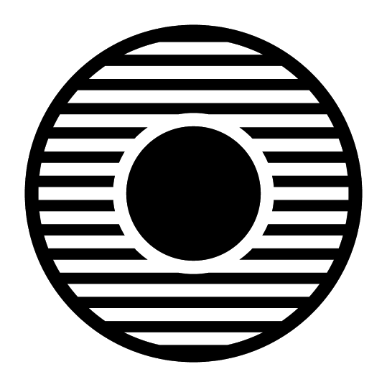  Contextualize | Why did Japan end its isolation? Why did Japan industrialize during the Meiji Period?  ➡ Directions: Read the text below and answer the questions that follow.
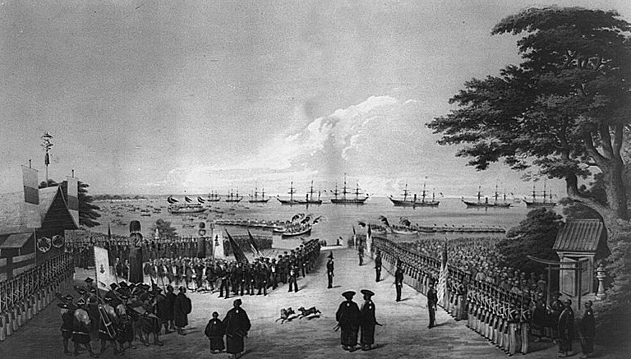
Landing of Commodore Perry, officers & men of the squadron, to meet the Imperial commissioners at Yoku-Hama July 14th 1853. Lithograph by Sarony & Co., 1855, after W. Heine.
Image is courtesy of Wikimedia Commons and is in the public domain

The Tokugawa Shogunate (1603-1867) isolated the island nation of Japan from the rest of the world for more than 200 years. During this period, the emperors ruled in name only. The real political power was in the hands of the shoguns all of whom were from the Tokugawa family. The Tokugawa maintained a feudal system in Japan that gave them, and wealthy landowners called daimyo, power and control. After negative experiences with Europeans in the 1600s, the shoguns were extremely resistant to trade because they viewed outsiders as a threat to their power.

Japan's isolation came to an end in 1853 when Commodore Matthew Perry of the United States Navy, commanding two steamships and two sailing vessels, sailed into Tokyo harbor. He forced Japan to end their isolation and open their ports to trade with U.S merchant ships. At the time, many industrialized nations in Europe and the United States were seeking to open new markets where they could sell their manufactured goods, as well as new countries to supply raw materials for industry. The Japanese, because of their years of isolation, had no navy with which to defend themselves, so they agreed to the demands of the United States. In 1854, the Treaty of Kanagawa was signed which permitted trade and opened Japanese ports to merchant ships.

Commodore Matthew Perry’s actions showed that Japan's ruling Shogunate was weak and unable to defend the nation against a threat from the Western powers. Convinced that modernization depended on abolishing [getting rid of] the Shogunate and the feudal order, a group of middle-ranking samurai overthrew the military government of the Shogun in 1868 and set to modernize and industrialize the country. The period of industrialization in Japan starting with the fall of the Tokugawa Shogunate is known as the Meiji Restoration (1868-1912).
Sources: Adapted from Asia for Educators, “Japan: History.” http://afe.easia.columbia.edu/tps/1750_jp.htm#edo
1. Before 1867, what was the political structure of Japan like? Who had the power?

2. Why did the Tokugawa government distrust foreigners?

3. Why did Commodore Matthew Perry enter the Tokyo harbor with military ships?

4. What were the effects of Commodore Matthew Perry’s demands?

Contextualize | Why did Japan industrialize during the Meiji Period? How did industrialization affect Japan?  ➡ Directions: Read the text below and answer the questions that follow.
The Meiji Restoration (1868-1912): Japan Industrializes and Modernizes
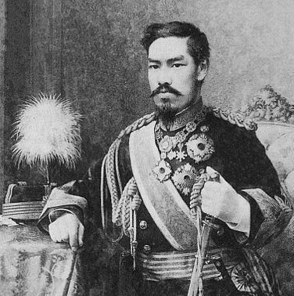  A sketched portrait of the Emperor Meiji, 1888.  Image is courtesy of Wikimedia Commons and is in the public domain | The arrival of warships from the United States and European nations, their advanced and formidable technology, and their ability to force the Japanese to agree to trade terms that were unfavorable for Japan sparked a period of rapid industrialization and modernization called the Meiji Restoration. This reaction was called the Meiji Restoration because Meiji (meaning “enlightened rule”) was the name taken by the emperor, and during this period he was “restored” as the leader of the nation, but like in monarchs of England or France at the time, he had very little real power. Under the slogan of "National Wealth and Military Strength," the Meiji government adopted a number of ideas from European countries and the United States relating to government, and technologies to bolster industry, communication, and transportation that greatly impacted Japanese and global history.
Directions: As you examine the following documents related to the Meiji Restoration, fill in the graphic organizer below with evidence of the effects of industrialization on Japan during this period.
Social Effects | Political Effects | Economic Effects

Document Set 1
The Constitution of the Empire of Japan: The Meiji Constitution (1890-1947)
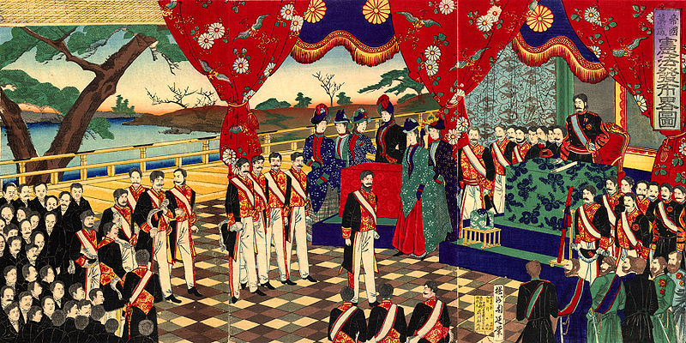
Illustration of the public acceptance of the Meiji Constitution (1889)
Image is courtesy of Wikimedia Commons and is in the public domain
During the Meiji Restoration, Japan’s leaders sought to create a constitution that would define Japan as a capable, modern nation deserving of Western respect while preserving their own power. The resultant document was influenced by European style governments and included a bicameral parliament (the Diet) with an elected lower house and a prime minister and cabinet appointed by the emperor. The emperor was granted supreme control of the army and navy. A small council of powerful leaders who helped overthrow the Tokugawa Shogunate advised the emperor and had actual power. Voting restrictions, which limited the electorate to about 5 percent of the adult male population, were loosened over the next 25 years, resulting in universal male suffrage.
Source: Adapted from Encyclopædia Britannica Online, s. v. "Meiji Constitution", accessed December 08, 2015, http://www.britannica.com/topic/Meiji-Constitution.
Excerpts from the Meiji Constitution (1889)
CHAPTER II.
RIGHTS AND DUTIES OF SUBJECTS
Article 20. Japanese subjects are amenable [open] to service in the Army or Navy, according to the provisions of law.
Article 23. No Japanese subject shall be arrested, detained, tried or punished, unless according to law.
Article 27. The right of property of every Japanese subject shall remain inviolate [untouchable].
Article 29. Japanese subjects shall, within the limits of law, enjoy the liberty of speech, writing, publication, public meetings and associations.
CHAPTER III.
THE IMPERIAL DIET
Article 33. The Imperial Diet shall consist of two Houses, a House of Peers and a House of Representatives.
Article 34. The House of Peers shall, in accordance with the ordinance concerning the House of Peers, be composed of the members of the Imperial Family, of the orders of nobility, and of those who have been nominated thereto by the Emperor.
Article 35. The House of Representatives shall be composed of members elected by the people, according to the provisions of the law of Election.
Source: Hirobumi Ito, Commentaries on the constitution of the empire of Japan, trans. Miyoji Ito (Tokyo: Igirisu-horitsu gakko, 22nd year of Meiji,1889). Hanover Historical Texts Project Scanned by Jonathan Dresner, Harvard University. https://history.hanover.edu/texts/1889con.html
Document Set 2
In addition to political changes, Japan changed economically and socially during the Meiji Restoration. The economy remained dependent on agriculture, but the government directed the development of strategic industries, transportation and communication. The first railroad was completed in 1872, and by 1890 there were more than 1,400 miles (2,250 kilometers) of railroad. All major cities were linked by telegraph by 1880. The government gave financial support to private companies and instituted a European-style banking system in 1882.
Source: Adapted from “Meiji Restoration.” Encyclopedia Britannica. https://www.britannica.com/event/Meiji-Restoration
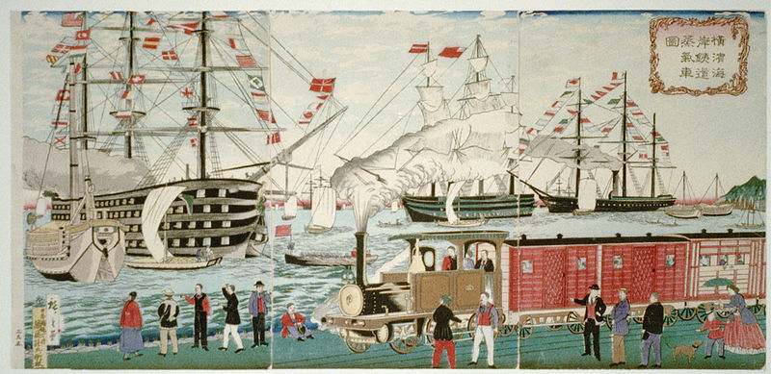
The picture of the steam locomotive railway at Yokohama seaside, drawn by Utagawa Hiroshige III, 1874.
Image is courtesy of Wikimedia Commons and is in the public domain

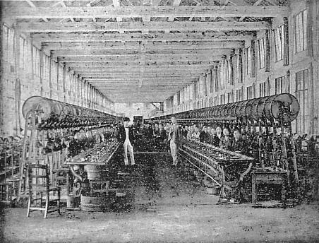  Photography of a Japanese silk factory in the early 1900s. The first factory of its kind was the Tomioka Silk Mill established in 1872 by the government to introduce modern machine silk reeling from France and spread its technology in Japan.  Image is courtesy of Wikimedia Commons and is in the public domain. | 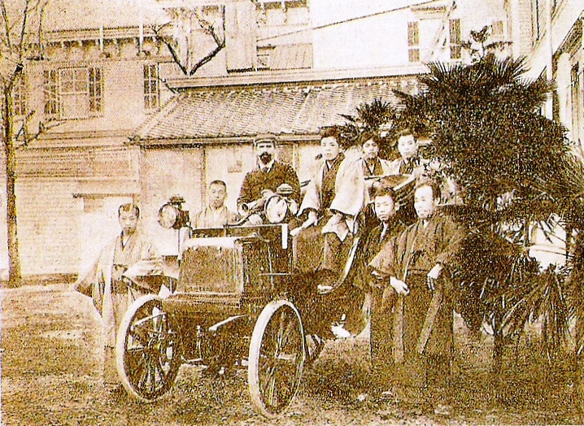  Photograph of the first automobile introduced to the Japanese in 1898 by the French.  Image is courtesy of Wikimedia Commons and is in the public domain.
Document Set 3
Their inability to defend themselves from Western nations inspired the Meiji Government to invest heavily in modernizing the country’s military.
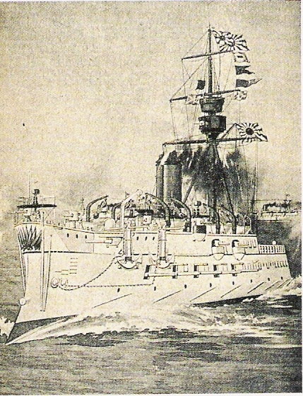  The Matsushima (pictured above), a Japanese warship built in 1885, was an example of the new Japanese fleet. Japan’s new navy was built by Japanese engineers and architects who were trained by French naval experts.  Image is courtesy of Wikimedia Commons and is in the public domain. | 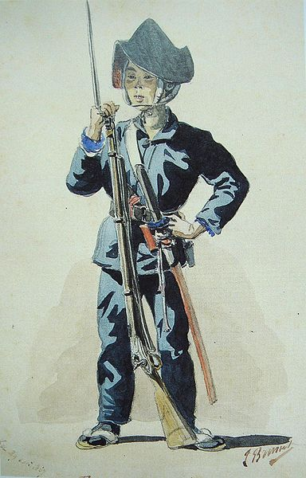  The Japanese asked several Western governments to help them modernize their military. The first country to do so was France. Above, is an image of a Japanese infantryman painted by one of the French men who trained the soldiers.  Image is courtesy of Wikimedia Commons and is in the public domain.

Document Set 4
Western science and technology were imported, and a program of “Civilization and Enlightenment” (bunmei kaika) promoted Western culture, clothing, architecture and intellectual trends. In the 1880s, a renewed appreciation of traditional Japanese values slowed this trend. An educational system was developed which, though it made use of Western theory and practice, stressed traditional samurai loyalty and social harmony. Art and literature turned from outright imitation of the West to a synthesis of Japanese and Western influences.
Source: Adapted from “Meiji Restoration.” Encyclopedia Britannica http://www.newworldencyclopedia.org/entry/Meiji_Restoration
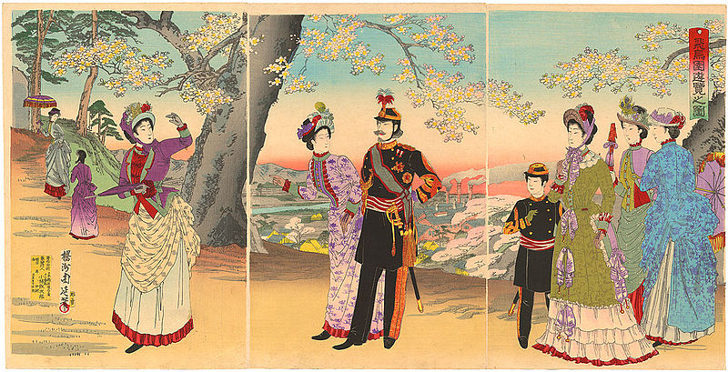
Woodblock print of Emperor Meiji and his family on a walk in a park , 1890.
Image is courtesy of Wikimedia Commons and is in the public domain
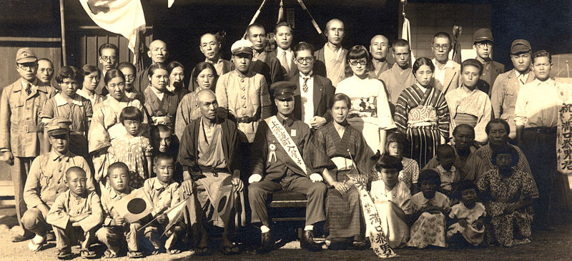
Photograph of a family from 1939 demonstrating the mix of Western influence and traditional Japanese dress that started during the Meiji Restoration.
Image is courtesy of Wikimedia Commons and is in the public domain

FA | SQ 13. Why did Japan industrialize during the Meiji Period? How did industrialization affect Japan?
Connect Cause and Effect | ➡ Directions: Complete the task below using the information you learned in this lesson and your knowledge of social studies.  Task 1. Describe one cause of industrialization in Japan in the late 19th and early 20th centuries  Task 2. Describe two social, political, and/or economic effects of industrialization on Japan in the late 19th and early 20th centuries

