`

SQ 10. How did Europeans and people of European descent gain, consolidate, and maintain power in South Africa?

Unit Essential Question(s): How do nations seek power and at what cost?
Supporting Question(s): How did Europeans and people of European descent gain, consolidate, and maintain power in South Africa?
Objective(s):
- Contextualize European imperialism in South Africa.
- Describe how Europeans and people of European descent gained, consolidated, and maintained power in South Africa.

Vocabulary

Word/Phrase  (part of speech) | Definition
Africa | the second largest continent located south of the Mediterranean Sea, east of the Atlantic Ocean, and west of the Indian Ocean
Afrikaans | a South African language developed from seventeenth-century Dutch
Afrikaners | a South African of Dutch ancestry
Berlin Conference | (1884–1885) was a meeting held in Berlin, Germany and organized by Otto von Bismarck, the first chancellor of Germany, during which European countries decided how they were going to divide up Africa for colonization
Boers | a South African of Dutch ancestry
colonization | the process of dominating a country’s political, economic, and/or cultural life
consolidate | to join together or combine
continent | a large expansive of continuous land of which there are seven- Africa, Antarctica, Asia, Australia, Europe, North America, South America
cultural | of or relating to culture
democratic | having to do with a system of government in which people vote
descent | the origin or background of a person
dispute | an argument; a thing that people do not agree on
Dutch | of or having to do with the Netherlands, or its people or language
epidemic | (n.) a widespread occurrence of a disease
ethnic | of or relating to a group of people with its own language, history, or culture
European | of or relating to Europe
gain | to get
historical context | the events that led to an event; includes the time period and larger historical trends as well as causes
imperialism | the policy of extending a country or empire's power and influence over another by taking over its land and/or government
industrial | related to turning raw materials into manufactured goods
Industrial Revolution | the period in which the production of goods shifted from hand production methods to complex machines. This period of industrialization resulted in social and economic changes. The Industrial Revolution started in Great Britain around 1750. The process of industrialization spread throughout the world in the following centuries.
innovation | a new method of addressing a problem
interior | the area inside of something
Khoisan | an ethnic group native to Southern Africa that included the Khoikhoi and the San
linguistic | of or pertaining to language
maintain | to keep in good condition
malaria | a serious disease carried by mosquitoes that causes chills, fever, and sweating
natural resources | materials the occur in nature and can be used for economic gain (to make money) like forests, water, fertile land, oil, or coal
Otto Von Bismarck | (1815-1898 ) a politician who was Minister President of Prussia and later Imperial Chancellor of the German Empire who was a leader of German unification. He practiced a policies called realpolitik and “Blood and Iron.”
parliament | a part of a government that makes laws; the legislative branch of government; referred to as Parliament in Great Britain and many other countries, but can have different names like Congress in the United States of America
power | influence or control over the behavior of people
regulate | to control or maintain
resistance | the attempt to prevent something
restrict | to keep within certain limits
Scramble for Africa | (1881-1914) a period of time during which European countries competed for control over African land and resources
smallpox | an infectious disease that was responsible for deadly epidemics, most notably in the Americas as a result of European colonization; the last naturally occurring case of smallpox was in 1977
steamboat | a boat that runs on steam power
Union of South Africa | (1910-1961) a self-autonomous territory of the British Empire created by combining the Cape Colony with the Boer states; the region became the Republic of South Africa in 1961
Zulu | an ethnic group in Southern Africa

Vocabulary for Document 2
Word/Phrase  (part of speech) | Definition
acquaint | to introduce or make familiar
autonomous | free and independent
avert | to keep from happening
Bantustan | also known as a Bantu homeland or a black homeland was a section of South Africa designated for black South Africans to live and own land; they were created to segregate South Africa
border | the line between two countries or other areas that have a government
cessation | a pausing or stopping
circumstance | a condition or fact connected with or having an effect on an event or situation
commence | to begin or start
commencement | the act of starting or beginning
defile | to dishonor or disgrace
deprive | To take away from, not allow to have
descent | the act or process of going downward
diplomacy | the practice of negotiating between nations or governments
enforce | make people obey
eviction | the process of being forced to leave a property
exclusive | keeping out all others
fend | to repel; ward off
fertile | able to produce farm crops or other plant life
govern | to rule or lead
hostility | the state of being unfriendly or full of hate
improper | showing bad manners; not acceptable
injustice | an act that is morally wrong
invasion | an act or instance of invading by an enemy or hostile army
lease | an agreement to pay to use another person's property for a certain period of time
loan | money or something else that is borrowed
mandate | (v.) to require by law or because of a vote of the people
massacre | the killing of a large number of people or animals in a cruel and violent manner
mediation | the process of negotiating an agreement between two or more parties
midst | in the middle of
military | having to do with soldiers or armies
misery | the middle of a situation
Moshoeshoe I | (1786-1870) the first chief of the Sotho Nation in Southern Africa
Natives' Land Act | (1913) a law in the Union of South Africa that restricted African land ownership to “reserves” that segregated black and white South Africans and gave white people more and higher quality land
permission | approval to do something, given by a person with authority
pillage | (v.) using violence to rob a place
proposal | a suggested plan
propose | to present or suggest as an idea to be considered
ravage | to damage or destroy, as by violent action
remembrance | the act or process of remembering
remonstrate | to say in opposition, protest, or objection
reserve | an area held especially for a group of people
scarcely | almost not; just barely
shameful | causing or deserving shame or disgrace
skirmish | a minor or preliminary battle between small military units
subject | a person who is ruled by another person
torment | to cause to feel great pain or distress
transaction | an act of doing business
unjust | unfair
vain | not leading to a desirable or lasting effect

Objective: | How did Europeans and people of European descent gain, consolidate, and maintain power in South Africa?  - Contextualize European imperialism in South Africa.  - Describe how Europeans and people of European descent gained, consolidated, and maintained power in South Africa.

Think Like a Geographer | Introduction  ➡ Directions: Examine the maps below and complete the See-Think-Wonder chart.

Africa, 1789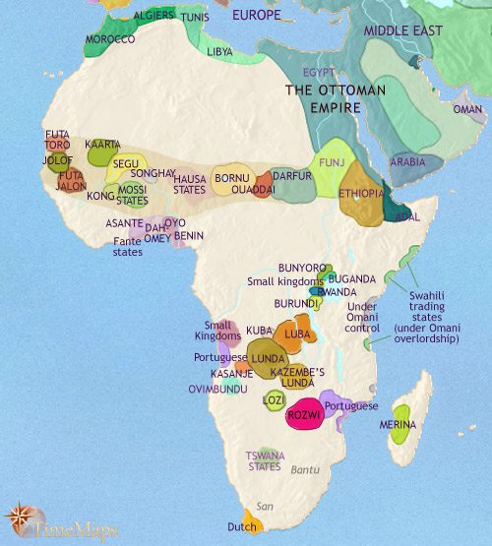 | Africa, 1914  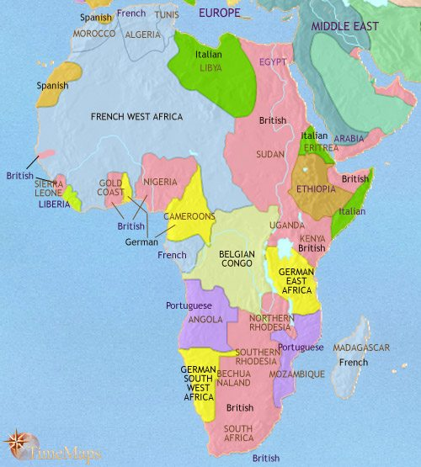  Source: Timemaps, Africa, 1914. | See  What do you see in the maps?
Think
What do you think changed in Africa from the 18th to 20th centuries?
Wonder
What questions do you have about the information in the maps?
Contextualize | What was the historical context for European imperialism in Africa and Southern Africa?  ➡Directions: Examine the map and text below. Answer the accompanying questions and annotate as you read by placing a “G” next to examples of methods that the British used to gain power in India, a “C” next to examples of methods they used to consolidate their power, and an “M” next to examples of methods used to maintain power, then add information to this graphic organizer.
The Berlin Conference and Scramble for Africa
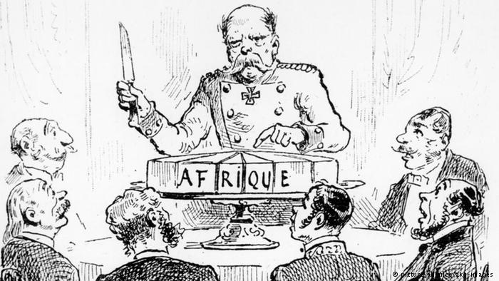  Cartoon about the Berlin Conference showing Otto von Bismarck carving a cake labeled “Africa” in French by Journal L'Illustration 1885  Image is courtesy of wikimedia commons and is in the public domain | 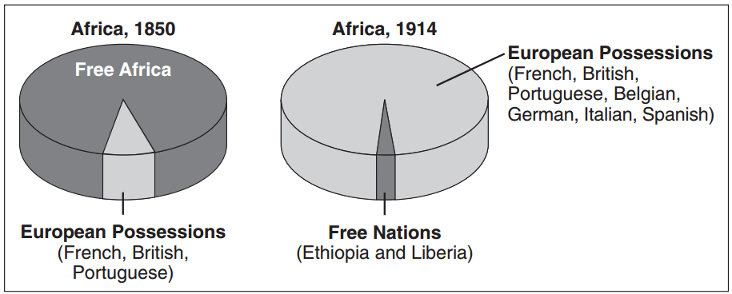
Though Europeans had trading posts on the coasts of Africa and Asia starting in the 15th and 16th centuries, they were unable to move into the interior of either continent because of resistance from the people who lived there and disease. This changed in the 19th century as the Industrial Revolution fueled European desire for more natural resources like gold, oil, rubber, diamonds, and ivory from Africa to fuel industrial production of goods and new innovations like the steamboat, advanced weapons, and medicine that lessened the effects of diseases like malaria led to the colonization of Africa. European nations competed for control of Africa during a period of time called the Scramble for Africa (1881-1914). During the Scramble for Africa, Europeans went from controlling 10% of Africa in 1870 to 90% of the continent in 1914. By 1914, only Ethiopia and Liberia were independent African nations not under the control of European powers.

Competition for control over Africa led to disputes between European countries and those disagreements led to the Berlin Conference (1884-1885). The Berlin Conference of 1884–85 was a meeting held in Berlin, Germany and organized by Otto von Bismarck, first chancellor of Germany. The purpose of the Berlin Conference was to regulate European colonization and trade in Africa by identifying which European nations would be allowed to control which parts of Africa. During the Berlin Conference, the European nations divided Africa up between themselves on maps, often drawing lines on the maps without any knowledge of the people who lived there and dividing up cultural, linguistic, and ethnic groups. No Africans were invited to the Berlin Conference and no Africans took part in deciding how the continent would be “carved up.” In the following decades, European governments sought to take over and control the sections of Africa that they agreed upon in Berlin in a little over three months.
1. What was the Scramble for Africa? | Africa, 1913  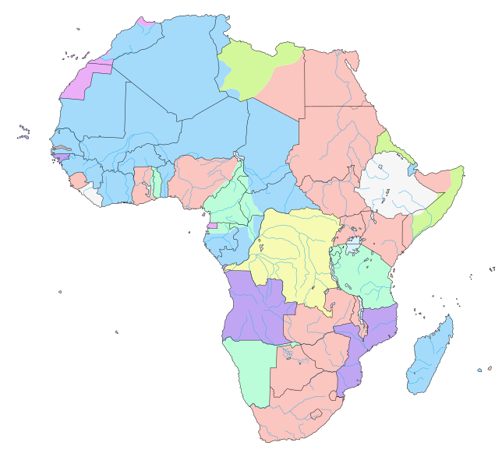  Belgium Great Britain Italy  Germany Spain Portugal  France
2. Who organized the Berlin Conference?
3. Why was the Berlin Conference organized?
4. Who attended the Berlin Conference? Who was not invited to attend the Berlin Conference? Why were they not invited?
5. What impact did the Berlin Conference have on Africa?

The Struggle for Southern Africa
Though nearly all of Africa was subject to European imperialism in the 19th and 20th centuries, we will focus on the colonization of South Africa and resistance to it because it is a case study that we will return to in later units.
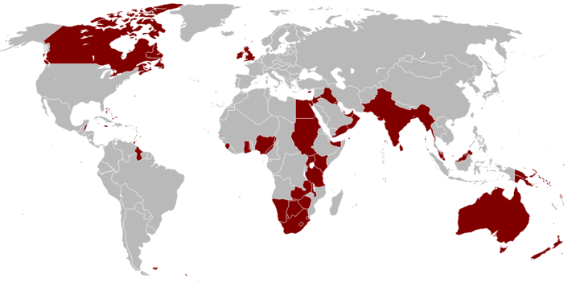  England  Southern Africa  Netherlands  A map of the British Empire in 1921 when it was at its height.  Image is courtesy of wikimedia commons and is in the public domain. | 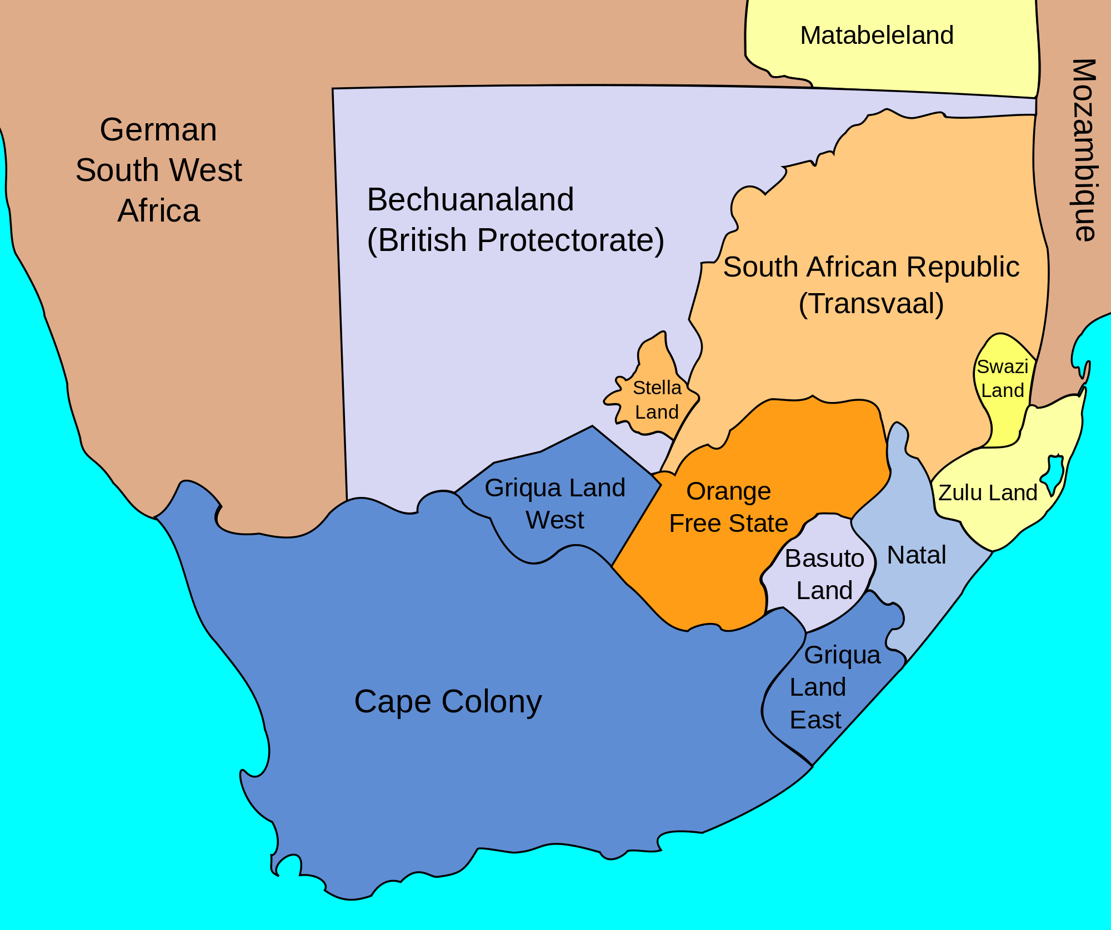  Map of South Africa showing British Possessions by John George Bartholomew, July, 1885  Image is courtesy of wikimedia commons and is in the public domain
The Dutch Control the Cape Colony
In 1652, the Dutch, Europeans from the country called the Netherlands, established a trading post called the Cape Colony in Southern Africa. They settled in the region, started farming, building communities, and forcing some of the indigenous South Africans into slavery while importing slaves from other areas. Later, other Europeans settled in the Cape Colony including Germans and the French. Over generations, these Europeans and their descendants saw themselves not as European but as South Africans and referred to themselves as the Boers, the Dutch word for farmer, or Afrikaners, even developing a different language called Afrikaans. It is difficult to pinpoint when the development of this new ethnicity took place, but it was first referred to in print in 1707. The indigenous people in the region were the Khoisan who resisted Dutch attempts to take over the land. After a series of wars, the Khoisan were forced off of their land and many other Khoisan people were killed by a smallpox epidemic brought to the Cape of Southern Africa by Dutch sailors.

In 1814, the British took over the Cape Colony from the Dutch. Over the next decades, British colonists settled in the Cape. The British freed the slaves held by the Boers and gave them equal rights including the right to vote to all men of any race. As a result of the British changes, many Boers left Cape Colony starting in 1835 in an event called the 'Great Trek' during which they traveled further north and east to found their own states including the Orange Free State and the South African Republic (or Transvaal) where they enacted laws that reflected their religious and cultural views including the idea that whites were superior to blacks. During their trek out of the Cape Colony and in their efforts to settle in the areas outside of it, the Boers came into conflict with African groups who lived on the land including the Batuso and Zulu. Eventually, the Boers, and later the British defeated African troops because of more advanced military technology.

The Discovery of Diamonds and Gold
In 1867, diamonds were discovered in an area of Southern Africa just inside the Orange Free State and in 1886 gold was discovered in the Transvaal. The diamonds and gold were located in the Boer lands. The discovery of these valuable natural resources caused two wars between the Boers and the British known as the Boer Wars (1880-1881; 1899-1902). In 1902, the Boers were defeated and the British took control of the former Boer lands as well as diamonds and gold in these areas.

The Formation of the Union of South Africa
In 1910, the Boers and British created the independent Union of South Africa which included the Cape Colony and the Boer republics. The Union of South Africa, though a part of the British Empire, was run independently and democratically. Black South Africans retained their right to vote in some of the states in the union, but could not vote in the former Boer states. Though the British won the Boer Wars after the Union of South Africa was created the Boers took control of the newly established parliament by winning elections and pushed forward their ideals which separated the races and restricted the rights of “natives.”

6. Who were the two European powers fighting over control of Southern Africa?

7. What caused the Boer War?

8a. What was the outcome of the Boer War for the British? | 8b. What was the outcome of the Boer War for the Boers? | 8c.What was the outcome of the Boer War for indigenous Africans and the former slaves imported from Dutch colonies?

Categorize | Corroborate | Document Analysis Activity: How did Europeans and people of European descent gain, consolidate, and maintain power in South Africa?  ➡Directions: Examine the documents and annotate as you read by placing a “G” next to examples of methods that Europeans and people of European descent used to gain power in South Africa, a “C” next to examples of methods they used to consolidate their power, and an “M” next to examples of methods used to maintain power.
Document Set 1
Illustrations created by Charles Edwin Fripp (1854-1906), a British war artist who covered the Zulu War and Boer Wars in South Africa. The image on the left depicts the Zulu warriors who fought against the Boers and the British in the northeastern section of Southern Africa. Boer settlers came into the area after leaving the Cape Colony and British troops came after diamonds were discovered in the area. The image on the right depicts a battle between British and Zulu troops in Zululand, South Africa in 1879.
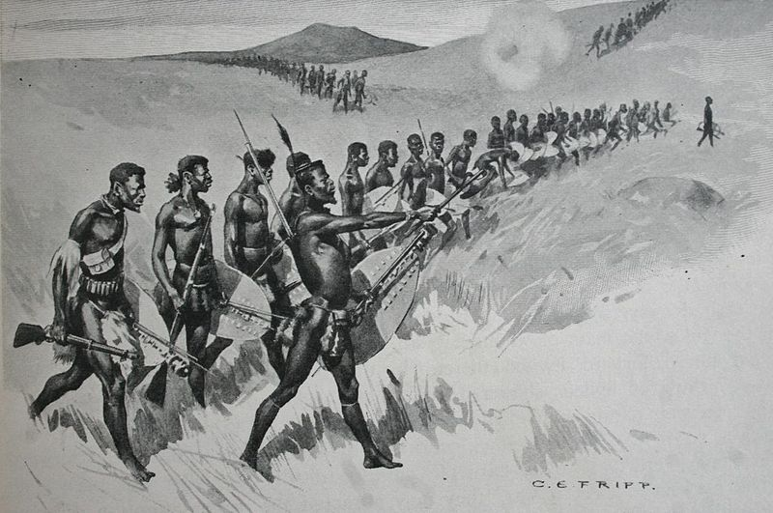  Image is courtesy of Wikimedia Commons and is in the public domain. | 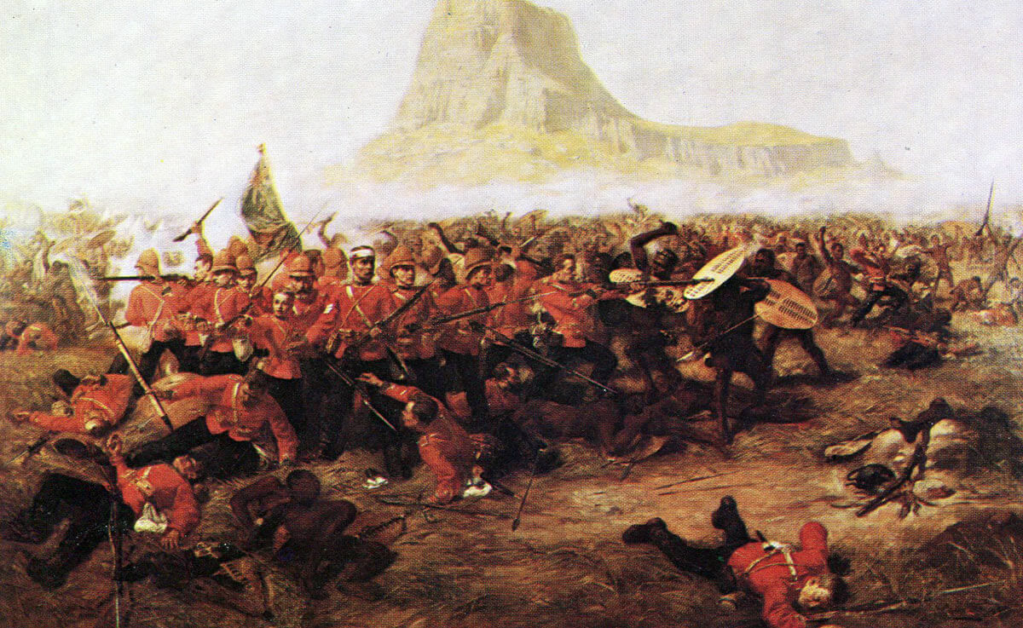  Image is courtesy of Wikimedia Commons and is in the public domain.

Document Set 2
Letter from Moshoeshoe I to Sir George Grey, 1858
Photograph of Moshoeshoe I (seated center) and his ministers.  Image is courtesy of Wikimedia Commons and is in the public domain. | Moshoeshoe (1786-1870), also spelled Moshweshewe and originally named Lepoqo, was the founder and first chief of the Sotho Nation in Southern Africa whose people are referred to as Basutos. He led his people against Boer and British invasions with diplomacy and in military campaigns. He gained support from African tribes because of his military success and formed relationships with British politicians to negotiate a border between Sotho land and Boer controlled area called the Orange Free State. In the 1830s, 40s, and 50s, Moshoeshoe successfully fended off Boer invasions into Sotho land and even gained territory, but lost much of it in conflicts with the Boers in the 1860s. Eventually, Moshoeshoe appealed to the British and asked for defense against the Boers in exchange for giving his people’s land to the British Empire. The British took control of the area known as Basutoland and was not a part of the Union of South Africa that formed in 1909. Today it is independent and known as Lesotho.  The following letter was sent from Moshoeshoe to Sir George Grey, the British Governor of the Cape Colony.  Source: Adapted from “Moshoeshoe,” Encyclopedia Britannica.

Your Excellency---it may scarcely appear necessary to lay before Your Excellency any lengthened details of what has taken place between the Orange Free State and myself. I know that you have followed with interest the transactions which have led to the commencement of hostilities, and you have heard with pain of the horrors occasioned by the war, at present suspended in the hopes that peace may be restored by Your Excellency's mediation.
Allow me, however, to bring to your remembrance the following circumstances: About twenty-five years ago my knowledge of the White men and their laws was very limited. I knew merely that mighty nations existed, and among them was the English. These, the blacks who were acquainted with them, praised for their justice. Unfortunately it was not with the English Government that my first intercourse with the whites commenced. People who had come from the Colony first presented themselves to us, they called themselves Boers. I thought all white men were honest. Some of these Boers asked permission to live upon our borders. I was led to believe they would live with me as my own people lived, that is, looking to me as to a father and a friend.
About sixteen years since, one of the Governors of the Colony, Sir George Napier, marked down my limits on a treaty he made with me. I was to be ruler within those limits. A short time after, another Governor came, it was Sir P. Maitland. The Boers then began to talk of their right to places I had then lent to them. Sir P. Maitland told me those people were subjects of the Queen, and should be kept under proper control; he did not tell me that he recognized any right they had to land within my country, but as it was difficult to take them away, it was proposed that all desiring to be under the British rule should live in that part near the meeting of the Orange and Caledon rivers.
Then came Sir Harry Smith, and he told me not to deprive any chief of their lands or their rights, he would see justice done to all, but in order to do so, he would make the Queen's Laws extend over every white man. He said the Whites and Blacks were to live together in peace. I could not understand what he would do. I thought it would be something very just, and that he was to keep the Boers in my land under proper control, and that I should hear no more of their claiming the places they lived on as their exclusive property. But instead of this, I now heard that the Boers consider all those farms as their own, and were buying and selling them one to the other, and driving out by one means or another my own people.
In vain I remonstrated. Sir Harry Smith had sent Warden to govern in the Sovereignty. He listened to the Boers, and he proposed that all the land in which those Boers' farms were should be taken from me. I was at that time in trouble, for Sikonyela and the Korannas [rival African tribes] were tormenting me and my people by stealing and killing; they said openly the Major [Warden] gave them orders to do so, and I have proof he did so. One day he sent me a map and said, sign that, and I will tell those people (Mantatis and Korannas) to leave off fighting: if you do not sign the map, I cannot help you in any way. I thought the Major was doing very improperly and unjustly. I was told to appeal to the Queen to put an end to this injustice. I did not wish to grieve Her Majesty by causing a war with her people. I was told if I did not sign the map, it would be the beginning of a great war. I signed, but soon after I sent my cry to the Queen. I begged Her to investigate my case and remove "the line," as it was called, by which my land was ruined. I thought justice would soon be done, and Warden put to rights.
I tried my utmost to satisfy them and avert war. I punished thieves, and sent my son Nehemiah and others to watch the part of the country near the Boers, and thus check stealing. In this he was successful, thieving did cease. We were at peace for a time. In the commencement of the present year my people living near farmers received orders to remove from their places. This again caused the fire to burn, still we tried to keep all quiet, but the Boers went further and further day by day in troubling the Basutos and threatening war. The President (Boshof) spoke of Warden's line, this was as though he had really fired upon us with his guns. Still I tried to avert war.
It was not possible, it was commenced by the Boers in massacring my people of Beersheba, and ruining that station, against the people of which there was not a shadow of a complaint ever brought forward. Poor people, they thought their honesty and love for Christianity would be a shield for them, and that the white people would attack in the first place, if they attacked at all, those who they said were thieves. I ordered my people then all to retreat towards my residence, and let the fury of the Boers be spent upon an empty land; unfortunately some skirmishes took place, some Boers were killed, some of my people also. We need not wonder at this, such is war! But I will speak of many Basutos who were taken prisoners by the Whites and then killed, most cruelly. If you require me to bring forward these cases, I will do so. I will however speak of the horrible doings of the Boers at Morija, they there burnt down the Missionary's house, carried off much goods belonging to the Mission, and pillaged and shamefully defiled the Church Buildings.
I had given orders that no farms should be burnt, and my orders were obeyed till my people saw village after village burnt off, and the corn destroyed, they then carried destruction among the enemy's homes. On coming to my mountain, the Boers found I was prepared to check their progress, and they consequently retired. My intention was then to have followed them up, and to have shown them that my people could also carry on offensive operations, believing that having once experienced the horrors of war in their midst, I should not soon be troubled by them again. My bands were getting ready to make a descent upon them, when the Boers thought proper to make request for a cessation of hostilities. I knew what misery I should bring upon the country by leaving the Basutos to ravage the Boer places, and therefore I have agreed to the proposal of Mr. J. P. Hoffman. I cannot say that I do so with the consent of my people, for many of those who suffered by the enemy were anxious to recover their losses. If they have remained quiet, it has been owing to my persuasions and my promises that they might have good hope of justice---Your Excellency having consented to act as arbitrator between the Boers and Basutos. With the expectation of soon meeting you, I remain, etc., etc.,
Mark X of Moshweshewe, Chief of the Basutos.
Source: From: G. M.Theal, ed., Records of Southeastern Africa (Capetown: Government of Capetown, 1898-1903). Scanned by Jerome S. Arkenberg, Cal. State Fullerton. The text has been modernized by Prof. Arkenberg. https://sourcebooks.fordham.edu/mod/1858basuto.asp

Document Set 3
Image is courtesy of South Africa History Online | The 1913 Natives’ Land Act  In 1910, the British and the Boers formed the Union of South Africa, a country that was part of the British Empire but was autonomously governed, meaning that the people who controlled the government in South Africa could rule it without much interference from the British government. In the first decade of the Union of South Africa, Boer representatives gained influence in the government by winning elections and passed laws that reflected their ideals and values over those of the British.  The Natives’ Land Act of 1913 was the first law passed by the Union of South Africa parliament that enforced the legal separation of blacks and whites that was common in the Boer states before the union in 1909, but had been illegal in the British controlled parts of the country like the Cape Colony. The law was designed so that only certain areas of the country could be owned by Africans who were named, “natives.” At the time the law was passed in June 1913, it is estimated that white people made up about 20% of South Africa’s population, and Africans about 70% of the population. The law mandated the following:  - 93% of the farmable and useful South African land was reserved for whites  - 7% of agricultural land was set aside on reserve for blacks  - Africans were forbidden from buying or leasing land outside those reserves, called Bantustans.  - Europeans, likewise, were unable to buy or lease land from Africans.  The Impact of the 1913 Natives’ Land Act  - White farmers issued notices of eviction to Africans  - Africans were denied access to land which they owned or leased  - Africans who were forced to move to the reserves often could not find enough fertile land to use for crops  - African families and their livestock roamed the countryside in search of accommodation and living space  - African farmers had to work for white landowners for small wages or small pieces of land  - White farmers took over land that was previously owned or farmed on by African farmers  - The government began to offer low-interest loans to White farmers which allowed them to make improvements to their farms and buy agricultural machinery and improve their yields.  - African farmers who owned land inside and outside the reserves did not receive any aid from the government in the form of loans and found it increasingly difficult to compete with White farmers who could use improved methods and now had more land for their crops.  Adapted from: http://www.parliament.gov.za/content/Land%20Act%20-%20Paper%20-%20Tshepo.pdf, http://www.sahistory.org.za/topic/natives-land-act-1913#sthash.3fAUqsYX.dpuf, http://www.bbc.co.uk/history/0/22786616, http://www.britannica.com/place/Southern-Africa/Southern-Africa-1899-1945#ref479812
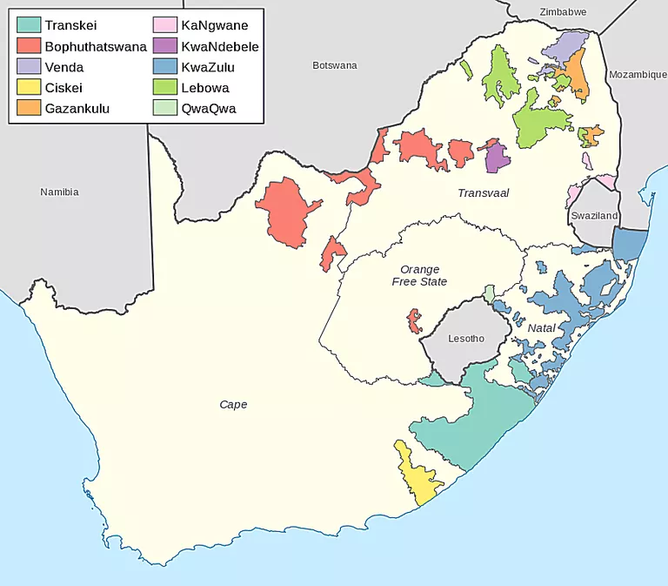
Map showing the Bantustans, areas where black South Africans were allowed to own land, as they were in the 1990s.
Source: Htonl/Directorate: Public State Land Support via Africa Open Data / CC BY-SA 3.0 via Wikimedia Commons https://www.thoughtco.com/pre-apartheid-era-laws-43472

FA | SQ 10. How did Europeans and people of European descent gain, consolidate, and maintain power in South Africa?
Contextualize  Corroborate | ➡ Directions: Respond to the questions below to contextualize European imperialism in South Africa.  Event: European imperialism in South Africa  Who?  individuals, groups of people, regions, nations involved  When?  date, year, era, “before __,” “after __”  Where?  continents, regions, countries, geographic features nearby, describe the geography if relevant  How?  describe the process that took place  Why?  use words and phrases like “led to,” because, and so to show connections between events and to explain why  Combined Contextualization:  Why did it happen when and where it happened?  Combine your responses from above to contextualize the event.

