SQ 5. What were the causes and effects of the Sepoy Rebellion?

Unit Essential Question(s): How do nations seek power and at what cost?
Supporting Question(s): What were the causes and effects of the Sepoy Rebellion?
Objective(s):
- Explain the causes and effects of the Sepoy Rebellion.

Vocabulary
Word/Phrase  (part of speech) | Definition
British East India Company | a trading company that was given the exclusive right to trade with India from the British government in the 1600s and who expanded their power to control most of India until being replaced by the British government in 1858
cartridge | a container, in the case of the Sepoy Rebellion, holding gun powder needed to load the enfield rifle
caste system | a rigid social class system in Hinduism based on the concept of reincarnation
cause | a reason something happens
colonial | relating to colonies
colonizer | a person or country who is involved in the domination of another country’s political, economic, and/or cultural life
Delhi | a city in India
discontent | a lack of satisfaction
disrespect | lack of respect
effect | something that happens because something else happened
gunpowder | an explosive substance used in weapons, dynamite, and fireworks
Hinduism | a polytheistic belief system formed in India; Hindus believe that when people die their souls are reincarnated based on their karma, which is determined by how well they followed their dharma. Hinduism breaks society up into castes which are social classes that one cannot move out of during their lifetime because the caste one is born into is determined by how they lived their past life. This belief creates a rigid social structure called the caste system.
independence | the state of being free from outside control
Islamic | relating to the religion of Islam
legislative | the part of a government that makes laws- parliament or congress
lubricate | to add something like oil or grease to allow smooth movement
military compound | a place used by the military, likely where soldiers or weapons are
Mughal Empire | (1526-1857) an Indian empire whose rulers were Muslim and claimed to be descended from Genghis Khan
nominate | to suggest someone for an elected position
Punjab | a province in south Asia that is currently split between India and Pakistan, but before 1947 was in India
resistance | the attempt to prevent something
rifle | a gun
sepoy | in India, formerly, a native soldier who served in a European army, esp. the British army
Sepoy Rebellion | (1857-1858) was a revolt of soldiers employed by the British East India Company against the Company, also known as India’s First War of Independence, the Great Rebellion, the Indian Mutiny, the Revolt of 1857, and the Indian Rebellion of 1857
Sikh | relating to someone who follows the religion Sikhism
treaty | an agreement between countries
violation | the act of breaking a local law
westernization | the process of adopting or being influenced by the cultural, economic, or political systems of Europe and North America

Objective: | What were the causes and effects of the Sepoy Rebellion?  - Explain the causes and effects of the Sepoy Rebellion.
Introduction
➡Directions: In the space below, write down anything you think of when you hear the word “resistance.”
resistance

What would make you resist against your government?

Contextualize | The Sepoy Rebellion (1857-1858)  ➡Directions: Watch this video entitled “Sepoy Mutiny- Revolt of 1857,” then read the information below and answer the accompanying questions.
The Sepoy Rebellion, also known as India’s First War of Independence, the Great Rebellion, the Indian Mutiny, the Revolt of 1857, and the Indian Rebellion of 1857, was a revolt of soldiers employed by the British East India Company against the Company. The rebellion was a major turning point in colonial India. As a result, the British government replaced the Company as the rulers of India and India became an official colony of Great Britain.

Since the 1600s, the British East India Company had operated trading posts in India and employed Indian soldiers, known as Sepoys, to protect the Company's interests. The Company’s influence and power in India grew over the next two centuries. They took control of land through military conquest and by the 1700s could arguably have been considered a “nation” within India.

1. Who were the sepoys?

2. What was the role of the British East India Company in India?

Long-Term Causes of the Sepoy Rebellion
1  Expansion of British Power in India  British Indian Army soldiers, 1895.  Image is courtesy of wikimedia commons and is in the public domain | 2  Westernization  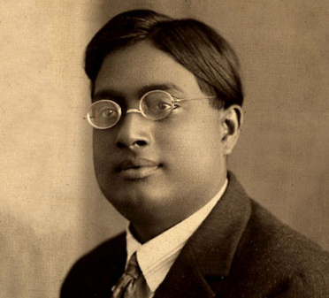  Photograph of Indian physicist, Satyendra Nath Bose, 1925.  Image is courtesy of wikimedia commons and is in the public domain | 3  Sepoys Outnumbered British Troops  Sepoy  Sepoy  British Soldier
The British East India Company took control of a large amount of India through force and through treaties that Indian princes who had no choice but to sign. Whenever possible, the British replaced Indian rulers with British officials. | Westernization, the process of changing a culture to be more “western” or European/American, was promoted by the British in India. They proposed changes to laws regarding Hinduism and the caste system, introduced a British education system, and British fashions became popular. | The British held all of the positions of power in the British East India Company, but they were not the majority of the Company’s soldiers. Two out of three soldiers working for the Company were Indian.

Short-Term Causes of the Sepoy Rebellion: The Spark
The immediate cause for the revolt was the introduction of the new Enfield rifle to the British Indian Army. To load it, the sepoys had to bite off the ends of lubricated cartridges that held the gunpowder for the rifle. A rumor spread among the sepoys that the grease used to lubricate the cartridges was a mixture of pig and cow lard. This was a problem because it was a violation of Hindu and Muslim religious practices to have contact with pig (Muslims) and cow (Hindu) products. There is no conclusive evidence that either of these materials was actually used on any of the cartridges in question. However, the perception that the cartridges were tainted added to the larger suspicion that the British were trying to undermine Indian traditional society. Disrespected, the soldiers reacted by arming themselves against their commanders, killing many of them, and taking control of military compounds and weapons.
Source: Adapted from Encyclopædia Britannica, “Indian Mutiny.” https://www.britannica.com/event/Indian-Mutiny

3. Explain the historical circumstances that led to the Sepoy Rebellion.
The Rebellion  At first, the sepoys successfully took control of a number of Indian cities including Delhi, but their lack of organization and lack of widespread support in the face of the British colonial system was not enough to retain control of India and drive out the colonizers. The sepoys did not have a clear leader or a command structure. Instead, they fought independently to defend the areas they controlled from the British. They also struggled to gain widespread support from Indians because of religious division. For example, when one of the leaders of the rebellion, a Muslim named Bahadur Shah Zafar declared himself Emperor of India, Sikhs from the Punjab region of India who had fought against Islamic rule under the Mughals refused to support him. In addition, the sepoys were only able to get support from some regional princes. Others, who had comfortable positions under British rule, supported the East India Company. Eventually, British reinforcements arrived with new supplies and weapons. The last rebels were defeated in Gwalior on June 20, 1858 and the warring parties signed a peace treaty on July 8, 1858 ending the war. | 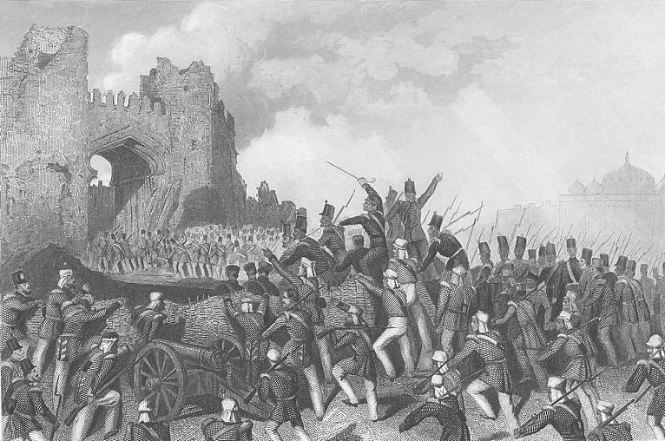  “The Capture of the Cashmere Gate, 14 Sept. 1857” an engraving published in London.  Image is courtesy of wikimedia commons and is in the public doma

in

4. Identify and explain three reasons why the sepoys were unable to free India from the British.

4a.

4b.

4c.

Effects of the Sepoy Rebellion
1  British Government Takes Control in India  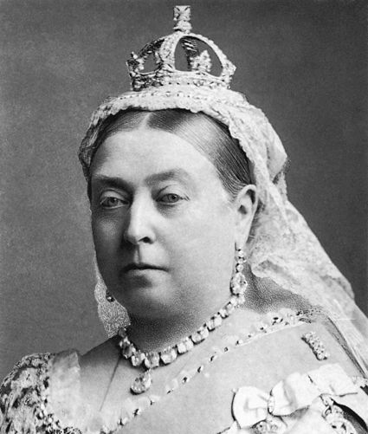  Picture of Queen Victoria of England by Bassano, 1887, became the official ruler of India.  Image is courtesy of wikimedia commons and is in the public domain | 2  Representation for Indians, but Little Power  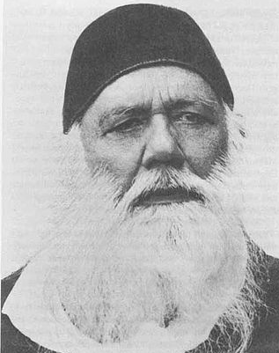  Photograph of Sir Syed Ahmed Khan, one of the Indian representatives on the Legislative Council.  Image is courtesy of wikimedia commons and is in the public domain | 3  Continued Modernization and Westernization of India  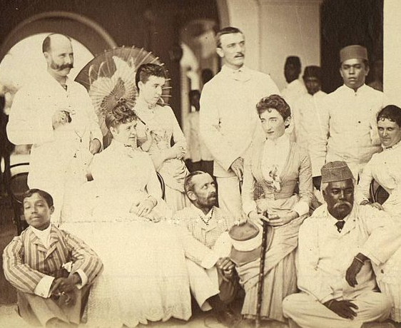  British men and women posing for a photograph with Indian men.  Image is courtesy of wikimedia commons and is in the public domain
As a result of their inability to control India, the British East India Company was replaced by the British government. India became an official British colony and was known as the “jewel in the crown” of the British Empire. The British government continued to administer India as the Company had, with strict control. They also exiled the last Mughal ruler and executed his sons. | The British realized that one of the reasons for the rebellion was that they did not consult with Indians on the policies they enacted in India. After 1861, an Indian-nominated group of representatives held seats in the Legislative Council, though they were “non-official members” and had little power. | The British continued the process of expanding their education system in India and public works programs (roads, railways, telegraphs, and irrigation). The British built up a communications and transportation network to prevent another rebellion like the one led by the sepoys. In addition, westernization continued, threatening traditional Indian society and the caste system.
Source: Encyclopædia Britannica Online, s. v. "Indian Mutiny", accessed December 18, 2015,http://www.britannica.com/event/Indian-Mutiny.

5. Based on the reading, describe three effects of the Sepoy Rebellion?

5a.

5b.

5c.

FA | SQ 5. What were the causes and effects of the Sepoy Rebellion?
Connect Cause and Effect | 1. Explain the historical circumstances that led to the Sepoy Rebellion. 2. Explain the effects of the Sepoy Rebellion.

